EventManagement-DM Help
Dhrityman Mukherjee
[Email address]
Abstract
[Draw your reader in with an engaging abstract. It is typically a short summary of the document.
When you’re ready to add your content, just click here and start typing.]
EventManagement Application
Dhrityman Help

Table of Contents
1. Introduction 2
2. Event Management Web Api 3
2.1. Create Web Api 3
2.1.1. Set the Connection String for new Database 5
2.1.2. Add the following NuGet Packages 8
2.1.3. Add DB Context Class to connect with database using Entity Framework 8
2.1.4. Add the following in the program.cs file 9
2.1.5. Add Model 9
2.1.6. Add Property for Model ‘Event’ in ‘ApplicationDBContext’ class 9
2.1.7. Go to the package Manager console for DB Migration 10
2.1.8. Run an INSERT query in the ‘Events’ Table 11
2.1.9. Create API ‘EventController’ 12
2.1.10. Create ‘EventDTO’ class 13
2.1.11. Create an endpoint to create an event 13
2.1.12. Create an endpoint to update an event 14
2.1.13. Create an endpoint to delete an event 15
2.1.14. Check the launch settings in ‘launchSettings.json’ file 16
3. Test the Api by using Postman 16
3.1.1. Copy the ‘application URL’ for ‘HTTPS’ 16
3.1.2. Test Api (GetEvents()) 17
3.1.3. Test Api (GetEvent(int id)) 18
3.1.4. Test Api (Createvent) 18
3.1.4.1. Test with valid data 18
3.1.4.2. Test with Invalid and uncomplete request 19
3.1.5. Test Api(UpdateEvent) 20
3.1.6. Test Api (DeleteEvent) 21
4. Call ‘EventManagerApi’ from a simple HTML page 22
4.1. Call the API from a simple HTML-based client which is opened in a web browser 22
4.2. Configure CORS in Api in the Program.cs file to allow requests from any origin 24
4.3. Open Client (EventsList.html) in a Web Browser 25
5. HTML Client Project (ASP.NET Core Empty) to Test 25
5.1. Add a new project in the solution file 25
5.2. Apply the code in ‘Program.cs’ to open HTML file 28
5.3. Configure Project Startup setting for the solution file 29
6. Create Blazor Client Application 30
6.1. Configure HttpClient in the Blazor application to connect Web API 33
6.2. Create an ‘Events’ folder in ‘Pages’ of the project 34
6.3. Add a new Blazor Component (EventList.razor) in the Events Folder 34
6.4. Add the EventList page reference in ‘NavMenu.razor’ under Layout folder 35
6.5. Add ‘Event’ Model class in the newly created folder ‘Models’ 37
6.6. Write code to display Event List in Blazor Component page (EventList.razor) under folder ‘Pages=>Event’ 37
6.7. Create Event 38
6.7.1. Create a new Model in ‘EventDto’ in the Model folder of the project ‘EventManagerBlazorApp’ 38
6.7.2. Create a new Blazor Component (Page) to create a new Event 38
6.7.3. Run the Application and check the validation error sent by the API 39
6.7.3.1. Load the Page 39
6.7.3.2. Click on ‘Add Event’ button 40
6.7.3.3. Verify the settings of the ‘Add Event’ button on the ‘EventList.razor’ Page 40
1.1.1.1. On Save and Cancel Button Click 41
2.1.1.1. Click on the Save button without any value, like Title 42
2.1.2. Code to show the validation message on the page sent by the API 43
2.2. Update Event 45
2.2.1. On the ‘EventList.razor’, verify the Following 45
2.2.2. Write code to read the supplied parameter to fetch Event details for the Event ID parameter 46
2.2.3. Complete the UI Design along with to display ‘Event ID’ in read-only mode 47
2.2.4. Write code for the Update and Cancel button clicks 47
2.2.4.1. Define OnClick events of Update and Cancel buttons. 47
2.2.4.2. Write the code for ‘UpdateEvent()’ to call Api to validate and save updated values. 48
2.2.4.3. Execute the application to verify ‘Edit Event’ functionality 48
2.3. Delete Event 49
2.3.1. Write the ‘DeleteEvent’ method on the ‘EventList.razor’ page 49
2.3.2. Call the ‘DeleteEvent’ method on the Delete Button click 49
3. Reference 50

Introduction

This document describes an ASP.NET Core RESTful API, a Blazor-based web application and a simple browser-based client to call the API for the following:
- Create a Web API for the following:
- Get All Events
- Get event details by event ID
- Create Event
- Update Event
- Delete Event
- Create a simple browser-based web client and call EventManagerWebApi to display all the events.
- Create a Blazor-based web application to call EventManagerWebApi to display and manage the Events for the following:
- Get All Events
- Get event details by event ID
- Create Event
- Update Event
- Delete Event

Event Management Web Api

Create Web Api
Open Visual Studio and Select ‘Create new Project’ with the following selection
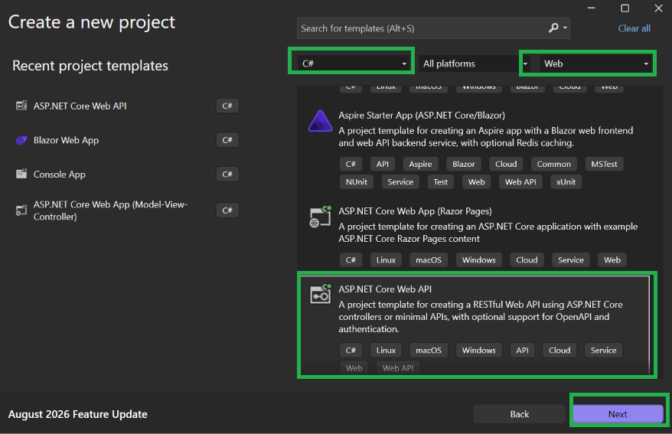

Project Name: EventManagementWebApi
Solution Name:EventManagement
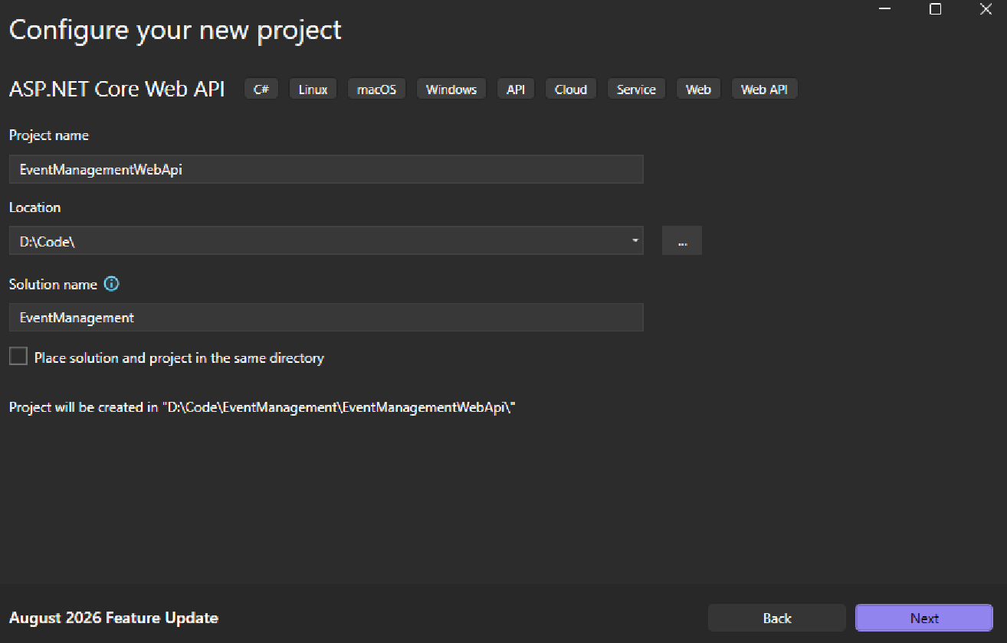

Select the following:
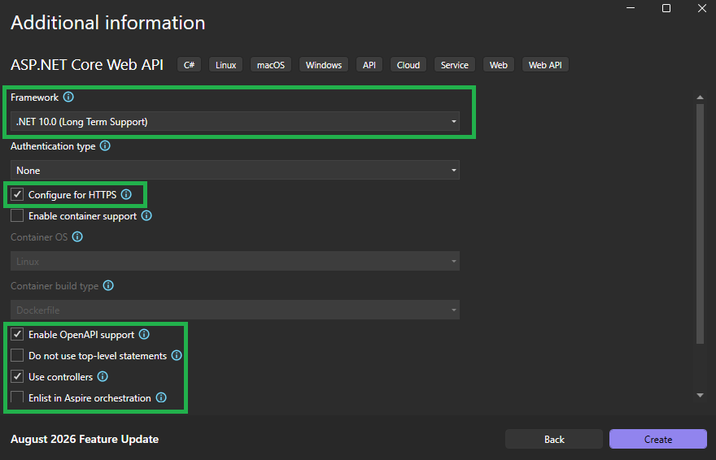

Delete the WeatherForecast.cs file
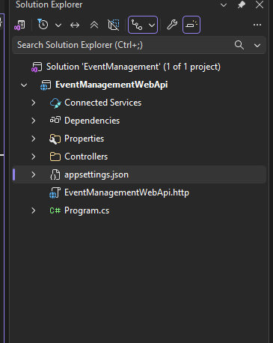

Set the Connection String for new Database
Open ‘Server Explorer’ and Click ‘Add Connection’
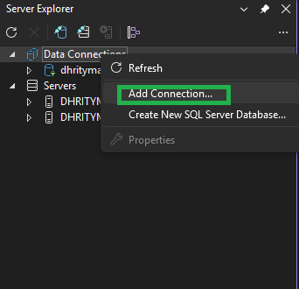

Create a new database named ‘EventManagementDB’ with the following settings
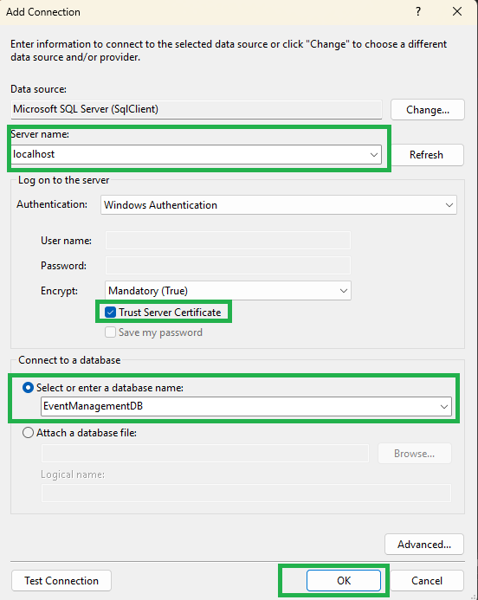

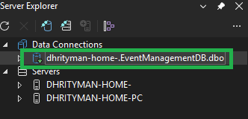
Copy the Connection String from the Properties window
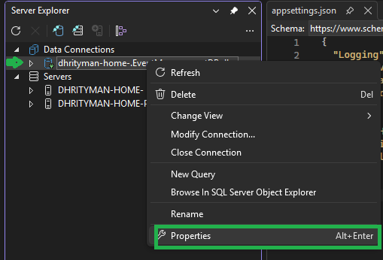

Copy the complete connection string:
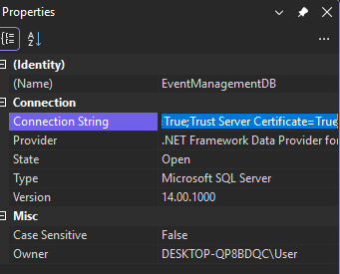

Go to ‘appsettings.json’ file and set the conntion string and remove space from ‘Trust Server Certificate‘
"ConnectionStrings": {
"DefaultConnection": "Data Source=localhost;Initial Catalog=EventManagementDB;Integrated Security=True;TrustServerCertificate=True;"
}

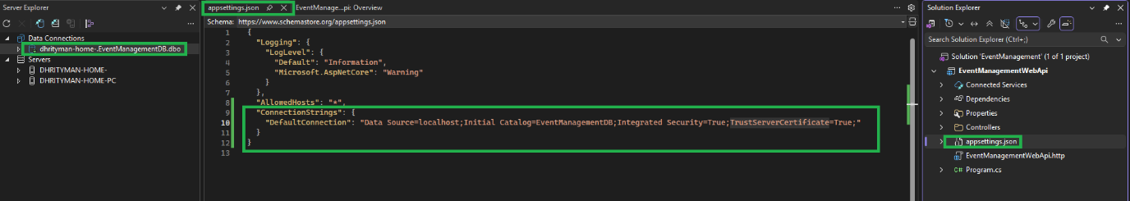

Add the following NuGet Packages
NuGet package Name | Version | Purpose
Microsoft.EntityFrameworkCore.SqlServer | 10.0.11 | Microsoft.EntityFrameworkCore.SqlServer is the EF Core database provider package for Microsoft SQL Server and Azure SQL.
Microsoft.EntityFrameworkCore.Tools | 10.0.11 | The Entity Framework Core tools help with design-time development tasks. They're primarily used to manage Migrations and to scaffold a DbContext and entity types by reverse engineering the schema of a database.

Add DB Context Class to connect with database using Entity Framework
Step 1: Add new folder ‘Services’
Step 2: Add new Class in ‘Servoces’ folder named ‘ApplicationDBContext’
Step 3: Inharit with ‘Microsoft.EntityFrameworkCore.DBContect’ class
Step 4: Create Constructor of ‘ApplicationDBContext’ class

Add the following in the program.cs file
Step 01: Add ‘ApplicationDBContext’ in the service contain
builder.Services.AddDbContext<ApplicationDBContext>(options =>
{
var connectionString = builder.Configuration.GetConnectionString("DefaultConnection");
options.UseSqlServer(connectionString);
});

Add Model
Step 01: Add ‘Models’ Folder
Step 02: Add new Model Class named as ‘Event’
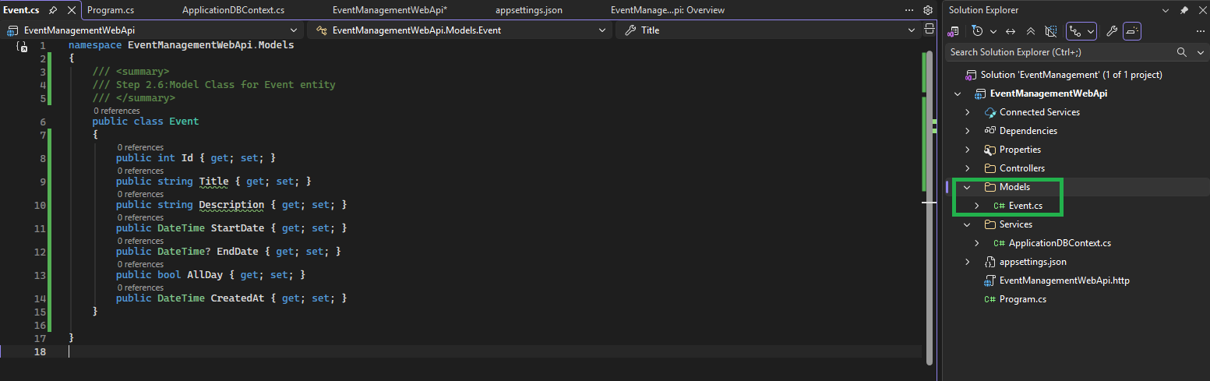

Add Property for Model ‘Event’ in ‘ApplicationDBContext’ class

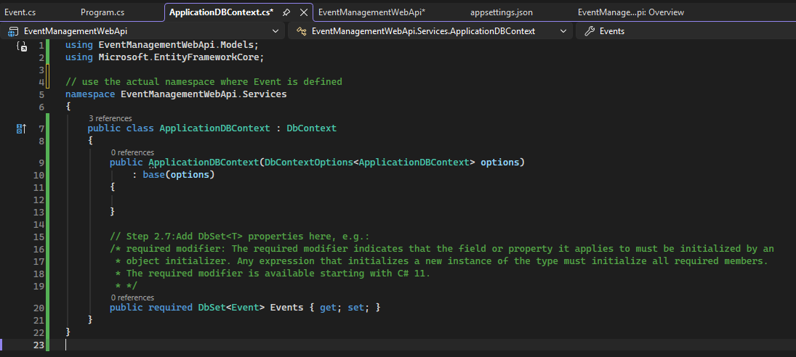

Go to the package Manager console for DB Migration
Run the following commands
Command | Comments
PM> add-migration FirstMigration | To add the ‘Migrations’ files and folder
PM> update-database | To Create actual tables in database

And verify in the database whether the actual tables have been created or not.

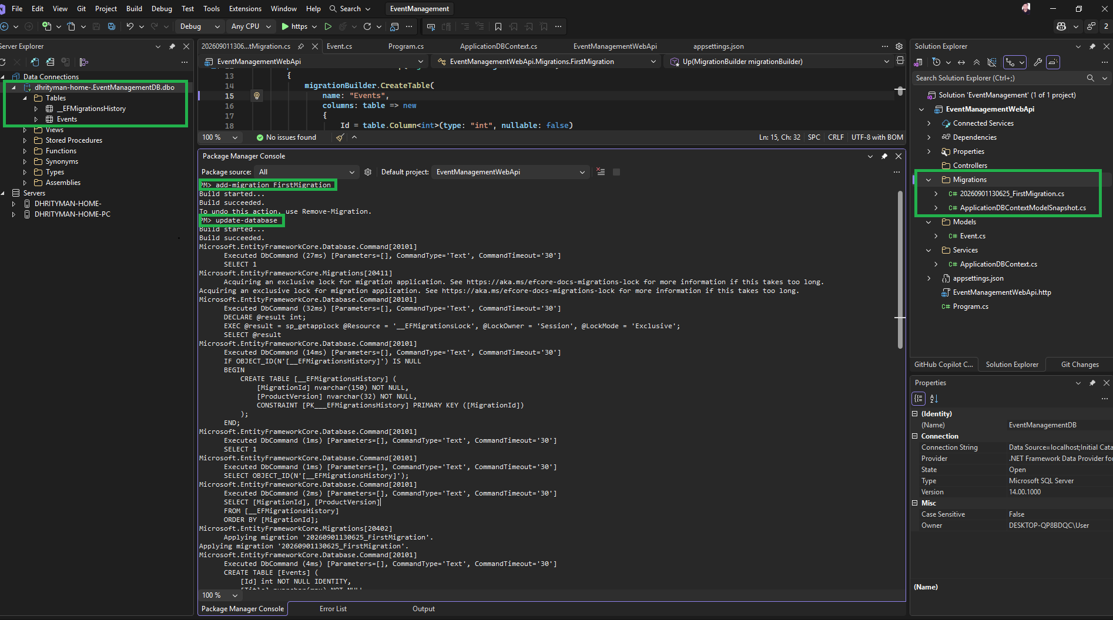

Run an INSERT query in the ‘Events’ Table
INSERT INTO Events (Title, Description, StartDate, EndDate, AllDay, CreatedAt) VALUES
('Blazor Conference', 'This is a Blazor Conference event', DATEADD(DAY,2,GETDATE()), NULL, 1, GETDATE()),
('C# Conference', 'This is a C# Conference event', DATEADD(DAY,2,GETDATE()), NULL, 1, GETDATE()),
('ASP.NET Conference', 'This is a ASP.NET Conference event', DATEADD(DAY,2,GETDATE()), NULL, 1, GETDATE()),
('ASP.NET CORE Conference', 'This is a ASP.NET CORE Conference event', DATEADD(DAY,2,GETDATE()), NULL, 1, GETDATE()),
('PYTHON Conference', 'This is a PYTHON Conference event', DATEADD(DAY,2,GETDATE()), NULL, 1, GETDATE()),
('RESTFULL API Conference', 'This is a RESTFULL API Conference event', DATEADD(DAY,2,GETDATE()), NULL, 1, GETDATE()),
('RAZOR Conference', 'This is a RAZOR Conference event', DATEADD(DAY,2,GETDATE()), NULL, 1, GETDATE()),
('Friends meeting', 'This is a Friends meeting event', DATEADD(DAY,2,GETDATE()), NULL, 1, GETDATE());

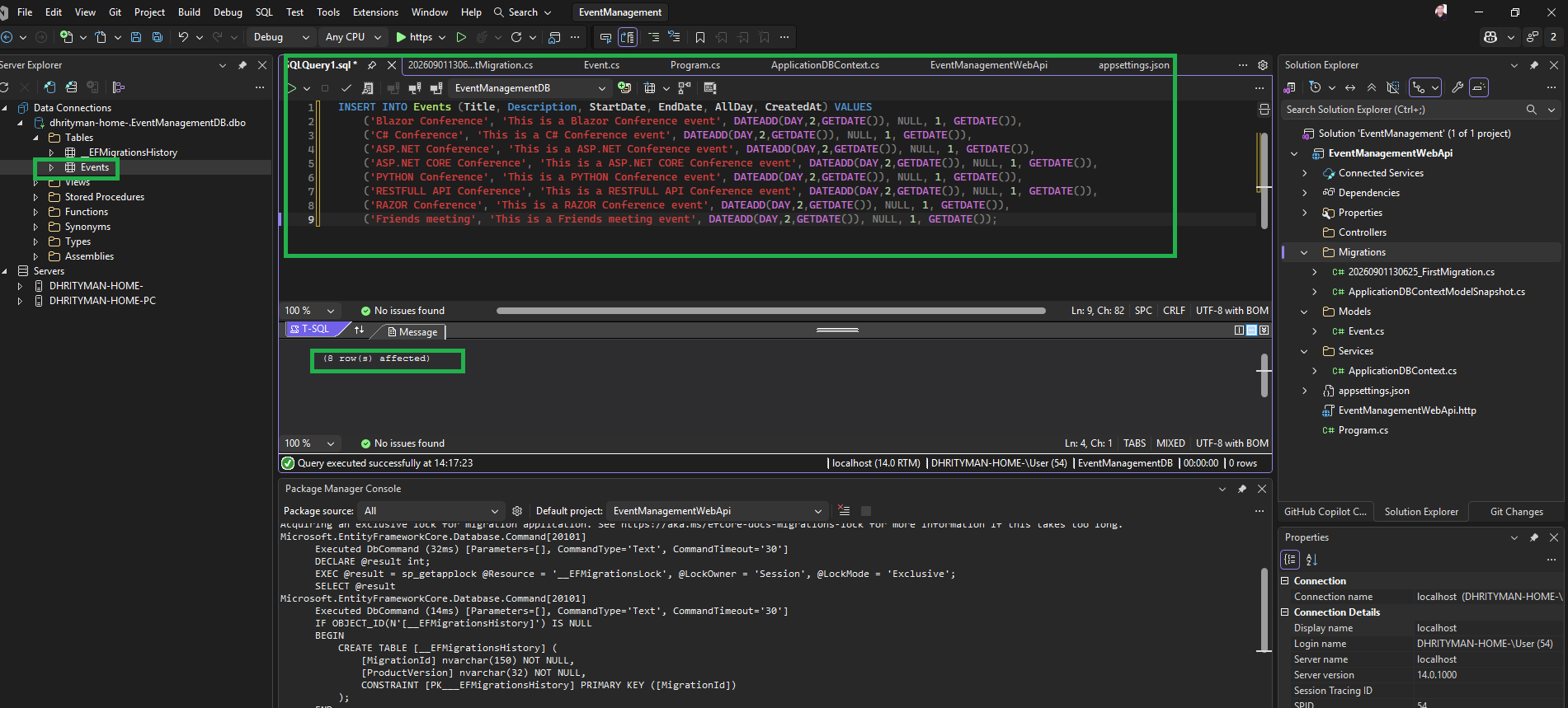

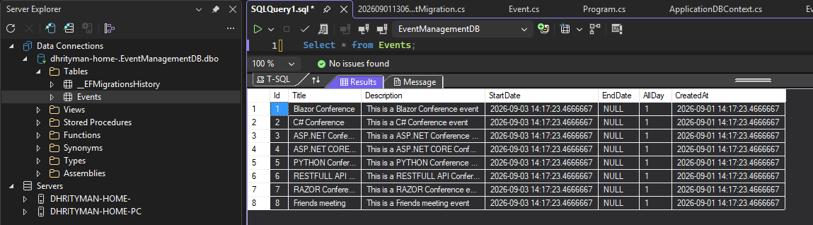

Create API ‘EventController’
Create API controllers to allow for CRUD operations for Events
Step 01:
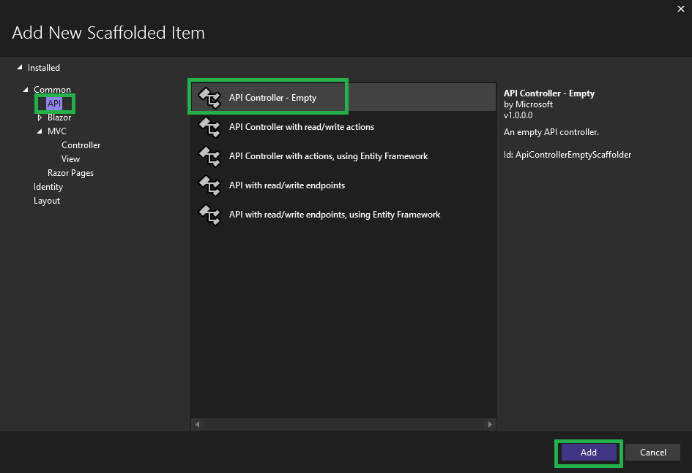

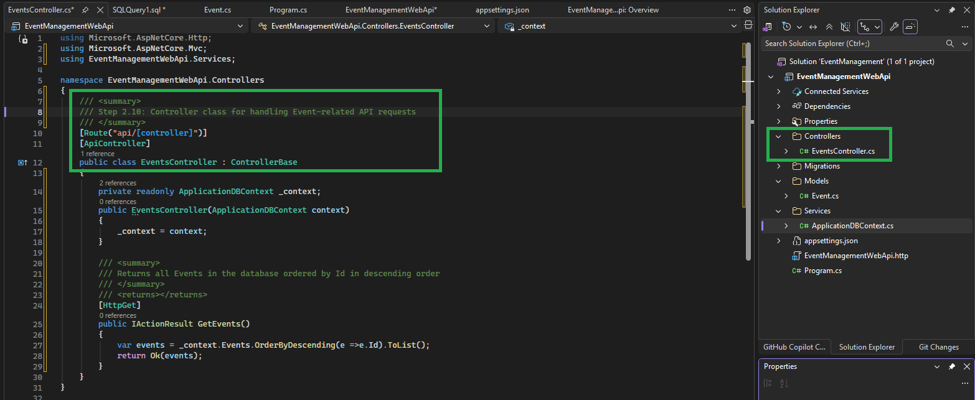

Step 02: Add the following API operations
API Name | Description
GetEvents() | Returns all Events in the database, ordered by Id in descending order
GetEvent(int id) | Returns a specific Event by its Id

Create ‘EventDTO’ class
Step 01: Create Dto folder under Model Folder
Step 02: Create EventDto class
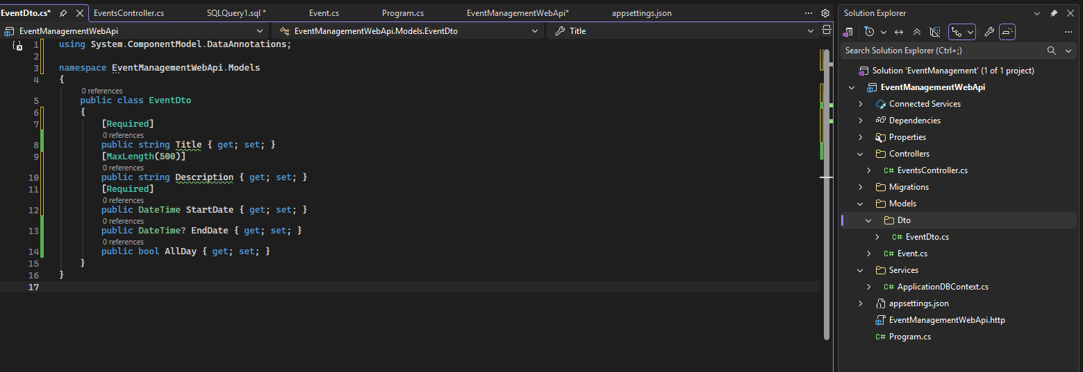

Create an endpoint to create an event
Create an endpoint to create events.
Go to the ‘EventController’ class
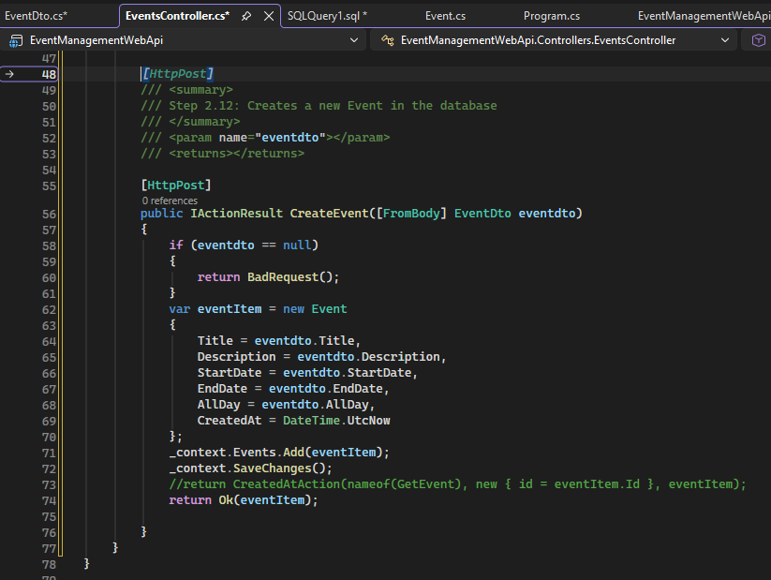

Create an endpoint to update an event
Create an endpoint to update events.
Go to the ‘EventController’ class
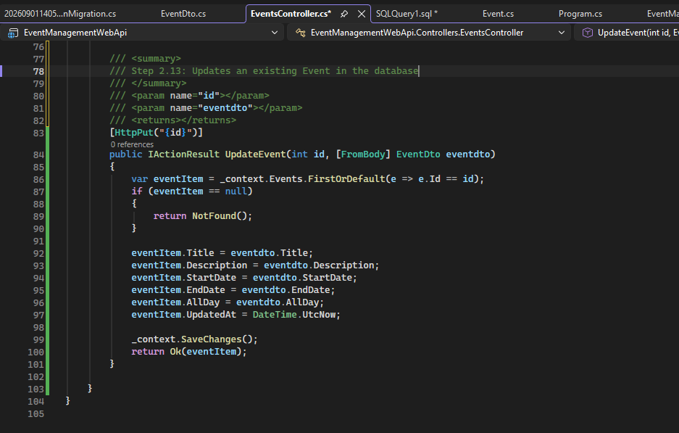

Create an endpoint to delete an event
Create an endpoint to delete events.
Go to the ‘EventController’ class
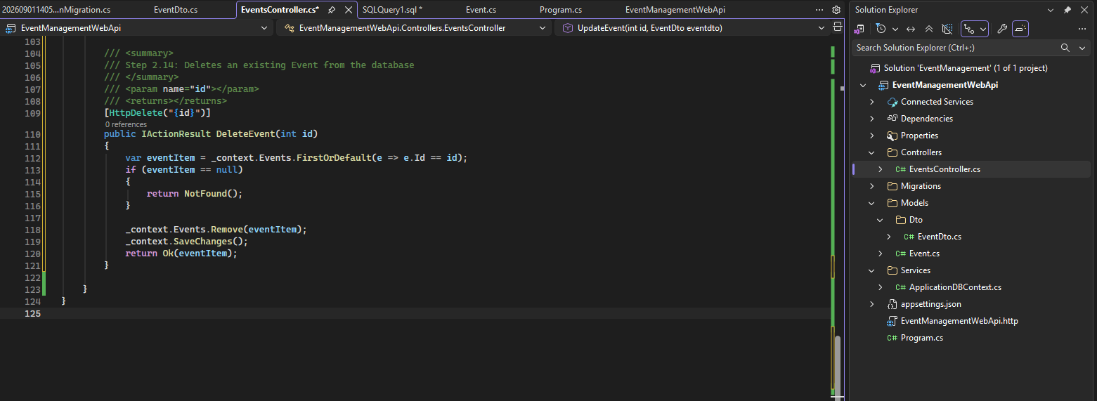

Check the launch settings in ‘launchSettings.json’ file
Go to the properties folder and open ‘launchSettings.json’ file
And check the ‘https’ launch setting, such as the URL.

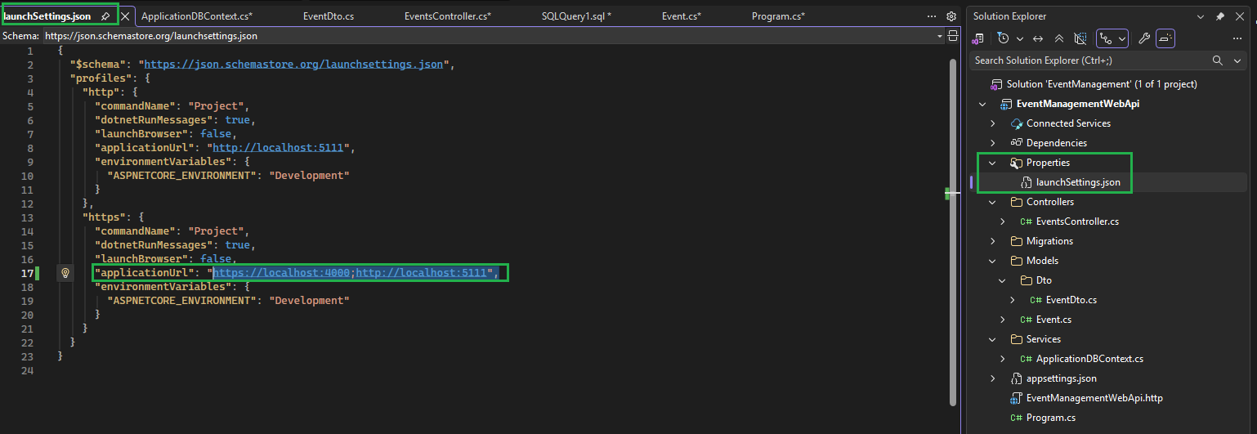

Test the Api by using Postman

Copy the ‘application URL’ for ‘HTTPS’
applicationUrl: "https://localhost:4000”

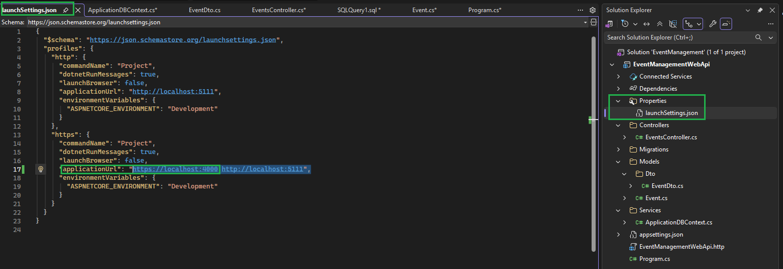

Add a Collections Item in Postman named as ‘EventManager’
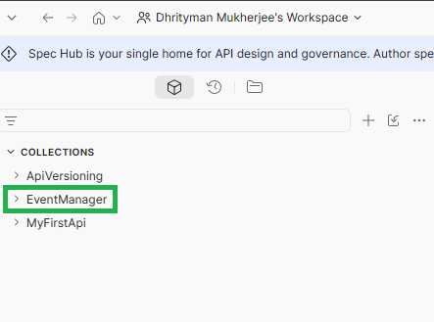

Test Api (GetEvents())

Test the Api with following application URL and setting
Application URL:https://localhost:4000/api/Events
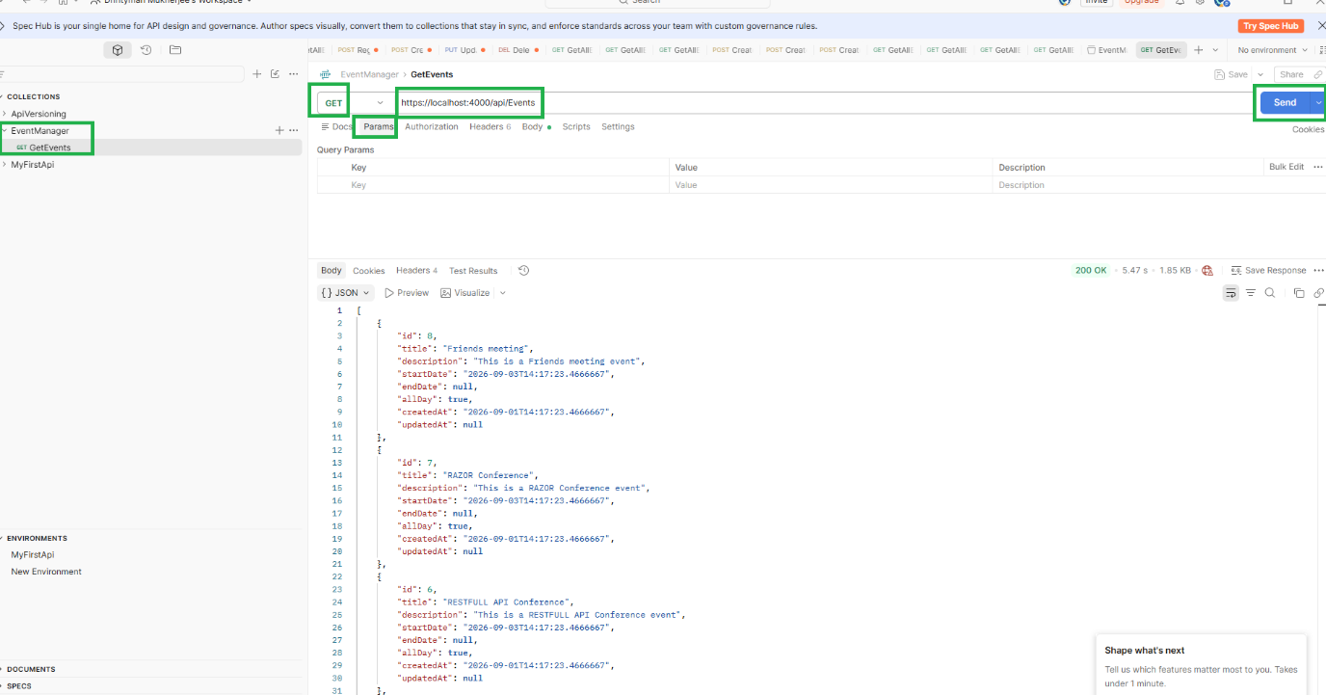

Test Api (GetEvent(int id))
To fetch the Event details for the Event Id=8
Application URL:https://localhost:4000/api/Events/8
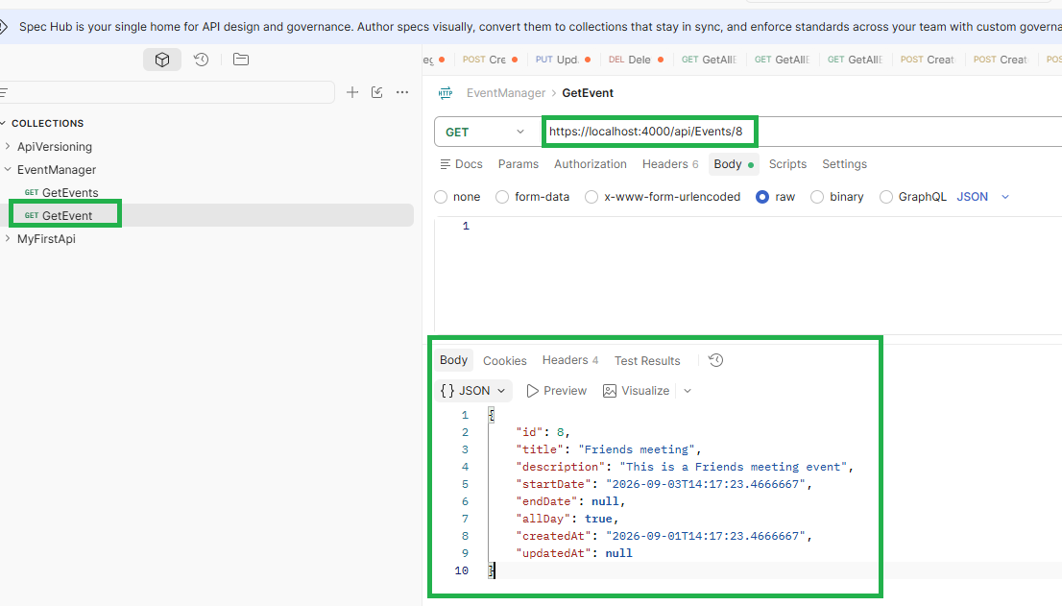

Test Api (Createvent)
Application URL:https://localhost:4000/api/Events
Type:Post

Test with valid data
Request | {  "title": "Family meeting",  "description": "This is a Friends meeting event",  "startDate": "2026-09-03T14:17:23.4666667",  "endDate": null,  "allDay": true,  "createdAt": "2026-09-01T14:17:23.4666667",  "updatedAt": null  }

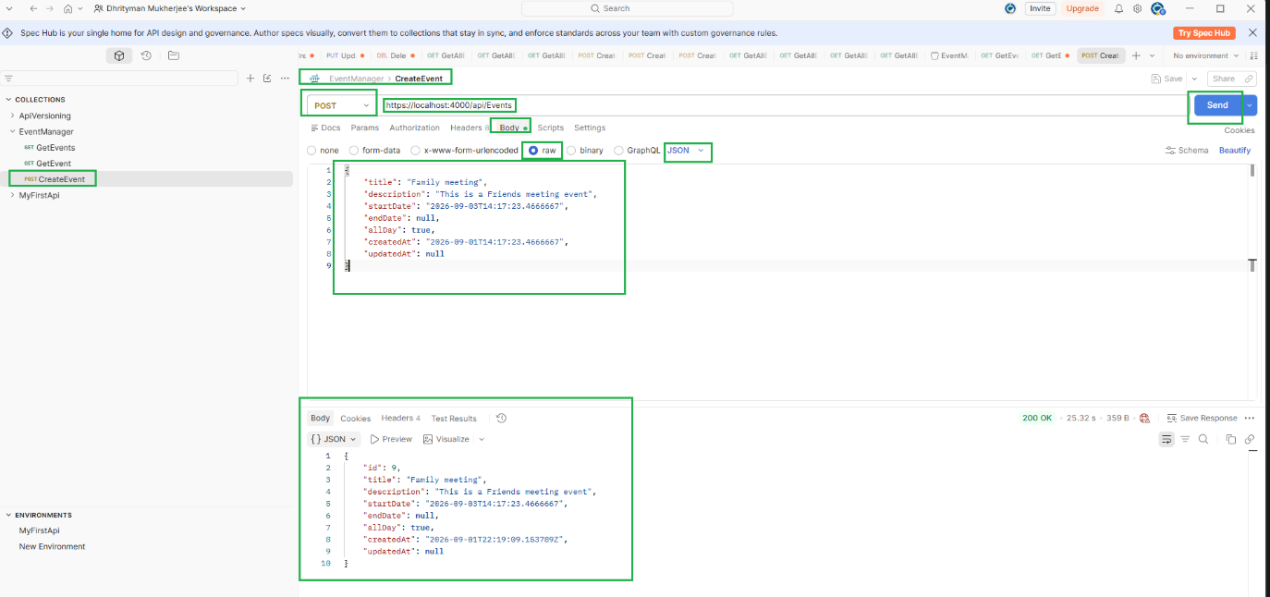

Test with Invalid and uncomplete request
Test Validation Error Message
Title is mandatory, so test Validation Error Message for Bad request

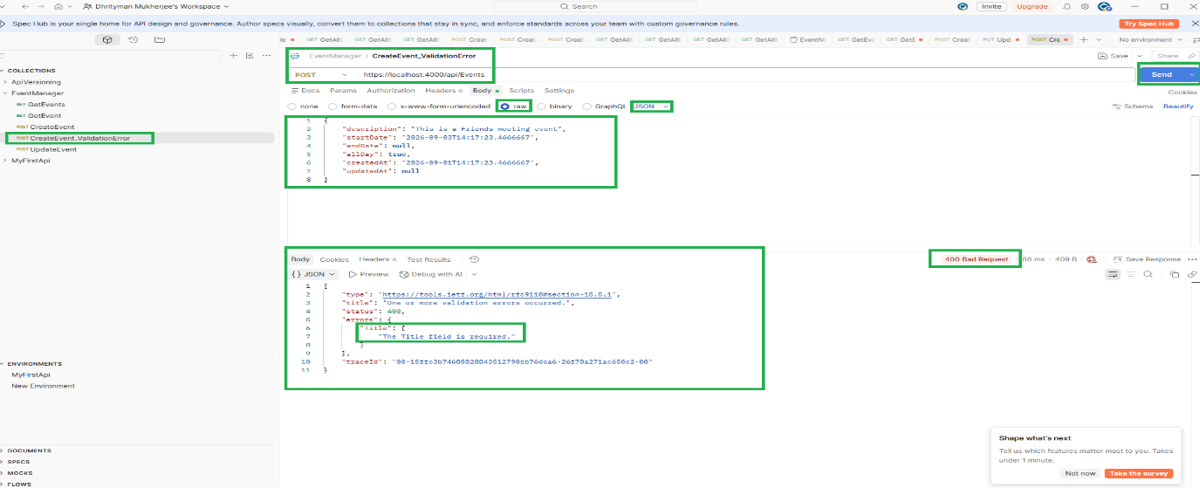

Test Api(UpdateEvent)
To update the Event ID=9
Application URL:https://localhost:4000/api/Events/9
Type:Post
Event Data or Parameter type | Request or Response data | Updated Type
Old Event Detail | {  "id": 9,  "title": "Family meeting",  "description": "This is a Friends meeting event",  "startDate": "2026-09-03T14:17:23.4666667",  "endDate": null,  "allDay": true,  "createdAt": "2026-09-01T22:19:09.153789Z",  "updatedAt": null  }
Request | {  "id": 9,  "title": "My Family meeting",  "description": "This is a Friends meeting event",  "startDate": "2026-09-03T14:17:23.4666667",  "endDate": "2026-09-03T16:17:23.4666667",  "allDay": true,  "createdAt": "2026-09-01T22:19:09.153789Z",  "updatedAt": null  } | Title  End Date
Response | {  "id": 9,  "title": "My Family meeting",  "description": "This is a Friends meeting event",  "startDate": "2026-09-03T14:17:23.4666667",  "endDate": "2026-09-03T16:17:23.4666667",  "allDay": true,  "createdAt": "2026-09-01T22:19:09.153789",  "updatedAt": "2026-09-01T22:37:47.659696Z"  }

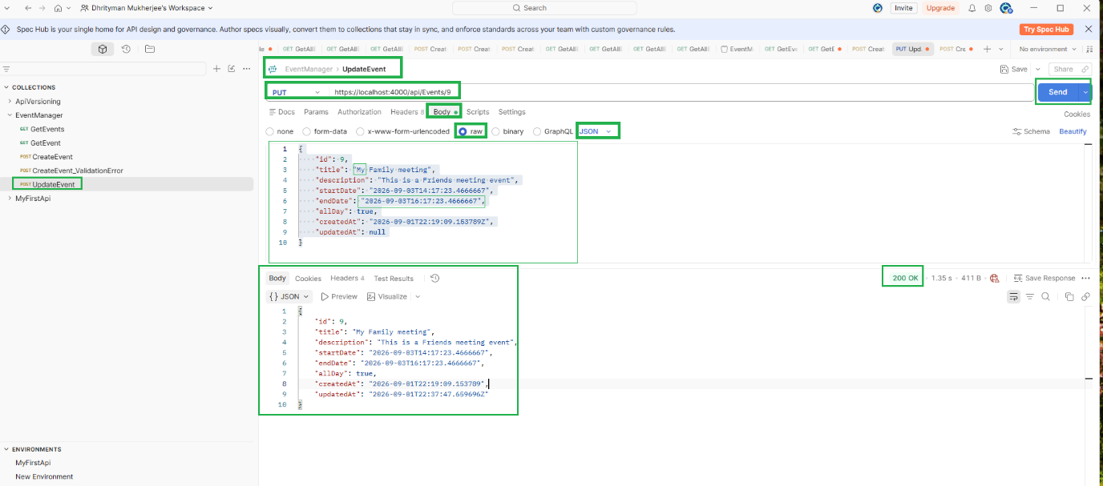

Test Api (DeleteEvent)

To update the Event ID=11
Application URL: https://localhost:4000/api/Events/11
Type:Delete

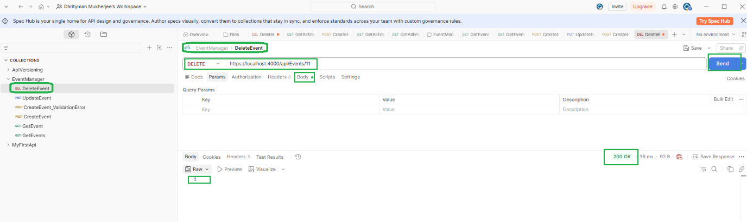

On the second call to delete the same Event (ID=11), an error is returned because the Event has already been deleted.
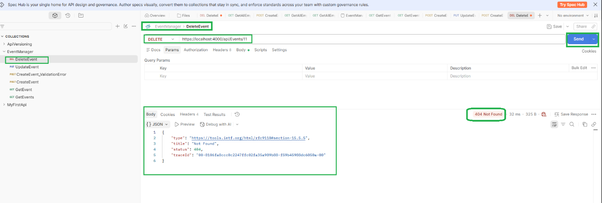

Call ‘EventManagerApi’ from a simple HTML page

Call the API from a simple HTML-based client which is opened in a web browser

<!doctype html>
<html lang="en">
<head>
<meta charset="utf-8">
<meta name="viewport" content="width=device-width, initial-scale=1">
<title>Home</title>
<link href="https://cdn.jsdelivr.net/npm/bootstrap@5.3.0/dist/css/bootstrap.min.css" rel="stylesheet">
</head>
<body>
<div class="p-3">
<h2 class="text-center mb-5">List of Events</h2>
<table class="table">
<thead>
<tr>
<th>ID</th>
<th>Title</th>
<th>Description</th>
<th>Start</th>
<th>End</th>
<th>All Day</th>
<th>Created At</th>
<th>Updated At</th>
</tr>
</thead>
<tbody id="tableBody"></tbody>
</table>
</div>

<script>
function loadTableData(data)
{
const tableBody=document.getElementById("tableBody");
data.forEach (event =>
{
let row=tableBody.insertRow();

let id=row.insertCell(0);
id.innerHTML=event.id;

let title=row.insertCell(1);
title.innerHTML=event.title;

let description=row.insertCell(2);
description.innerHTML=event.title;

let start=row.insertCell(3);
start.innerHTML=event.start;

let end=row.insertCell(4);
end.innerHTML=event.end;

let allDay=row.insertCell(5);
allDay.innerHTML=event.allDay;

let createdAt=row.insertCell(6);
createdAt.innerHTML=event.createdAt;

let updatedAt=row.insertCell(7);
updatedAt.innerHTML=event.updatedAt;

});
}

fetch("https://localhost:4000/api/Events")
.then((response) => response.json())
.then((data) => loadTableData(data))
.catch((error) =>
{ console.log("error: ", error)
});
</script>

<script src="https://cdn.jsdelivr.net/npm/bootstrap@5.3.0/dist/js/bootstrap.bundle.min.js"></script>
</body>
</html>

Configure CORS in Api in the Program.cs file to allow requests from any origin

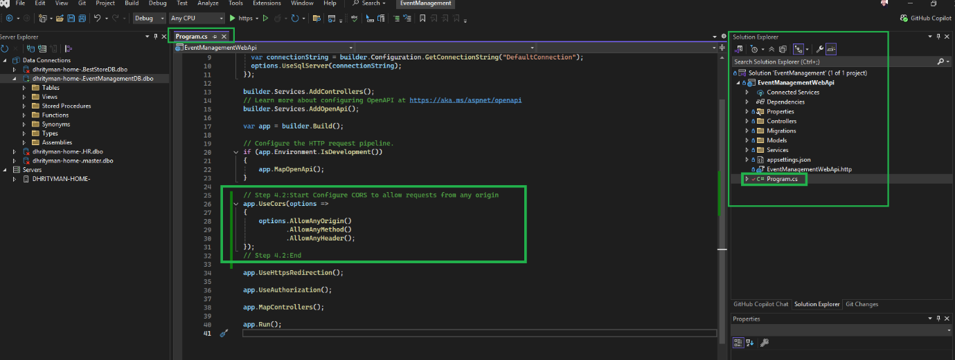

// Step 4.2:Start: Configure CORS to allow requests from any origin
app.UseCors(options =>
{
options.AllowAnyOrigin()
.AllowAnyMethod()
.AllowAnyHeader();
});
// Step 4.2:End

Open Client (EventsList.html) in a Web Browser

To display all Events data supplied by the RESTful API (EventManagerWebApi)
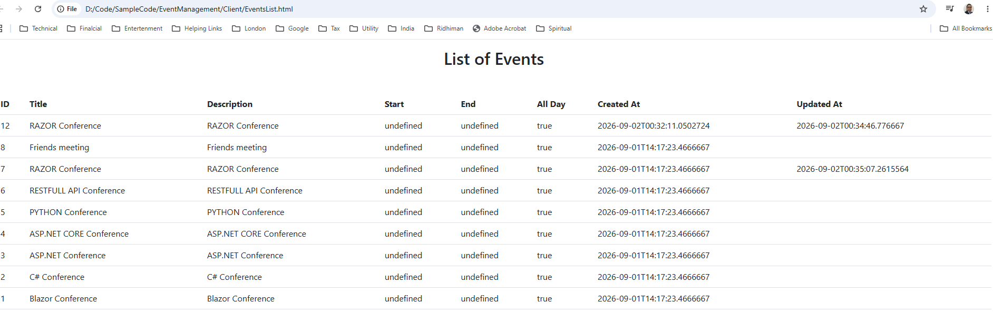

HTML Client Project (ASP.NET Core Empty) to Test

Add a new project in the solution file
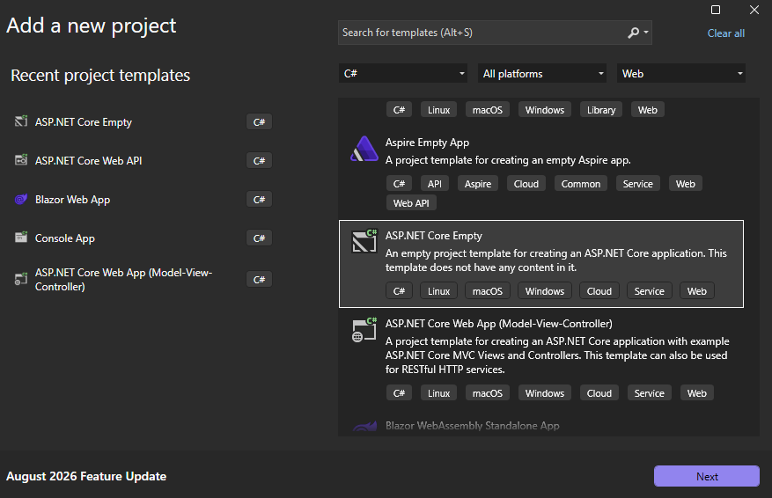

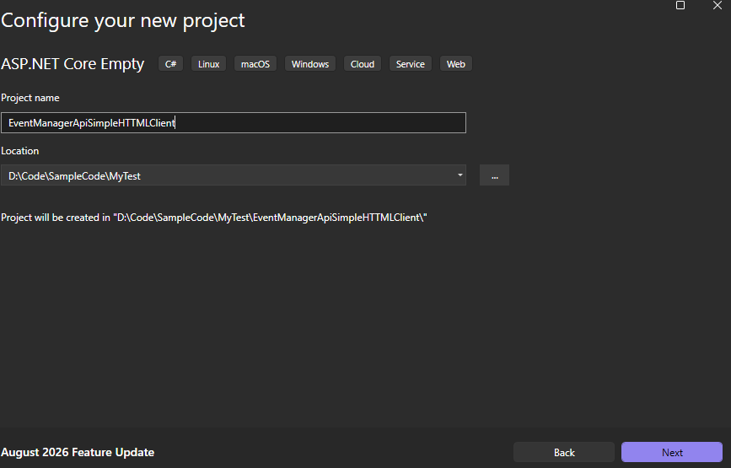

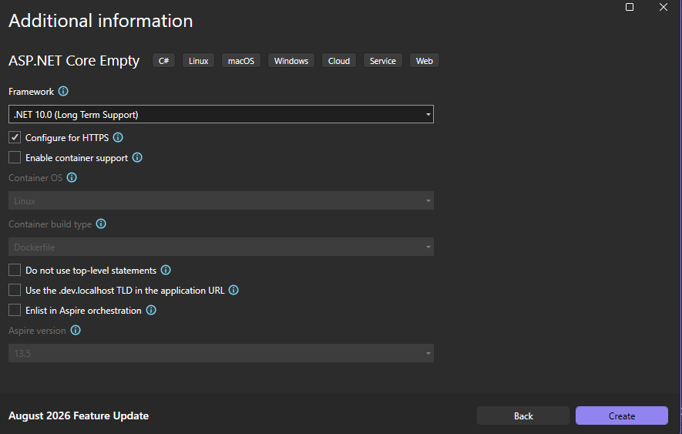

Add ‘EventsList.html’ in ‘EventManagerApiSimpleHTTMLClient’ Project
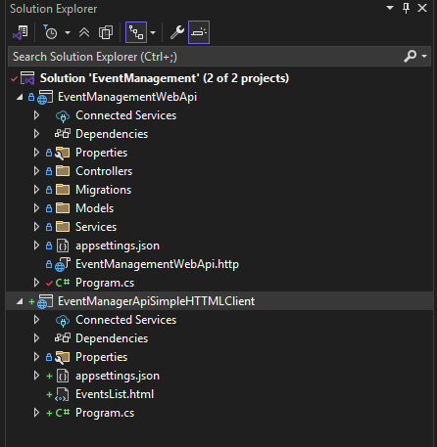

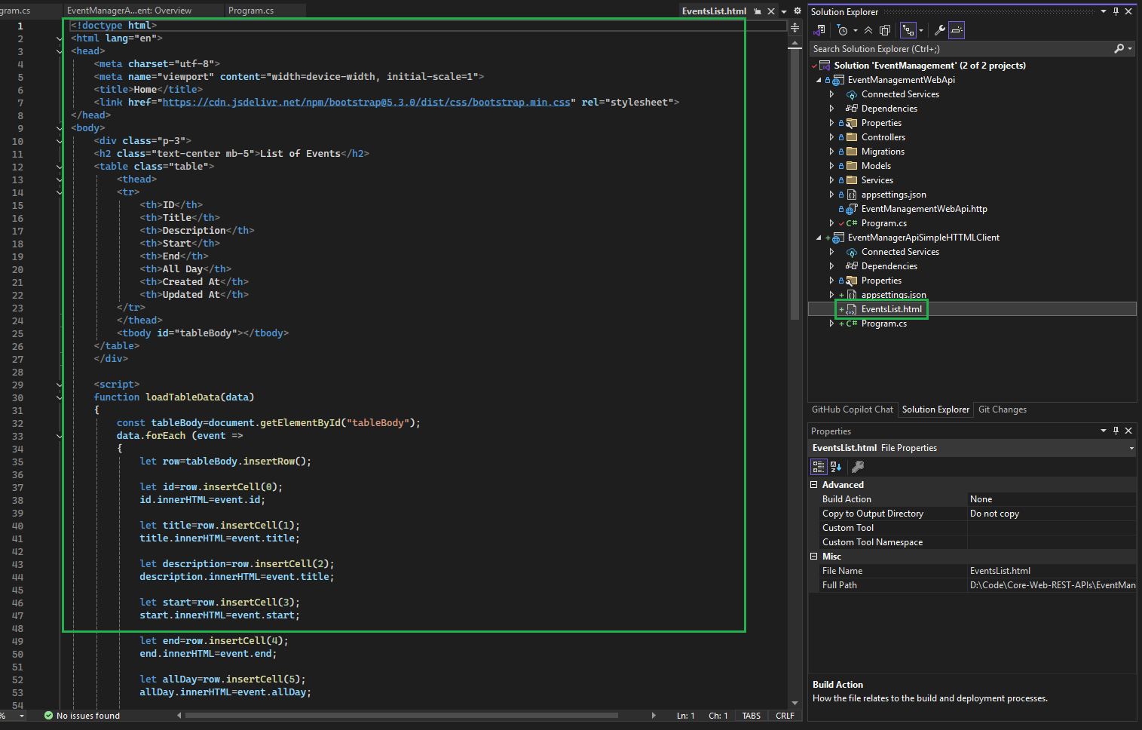

Apply the code in ‘Program.cs’ to open HTML file
var psi = new ProcessStartInfo("EventsList.html") { UseShellExecute = true };
System.Diagnostics.Process.Start(psi);

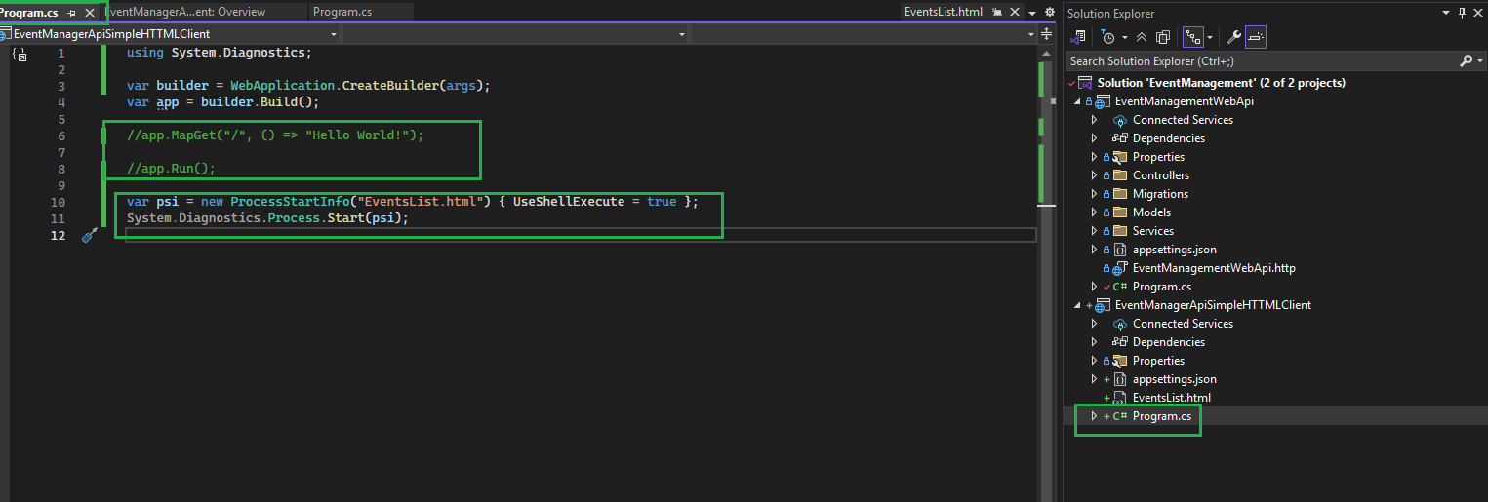

Configure Project Startup setting for the solution file
Go to property of Solution file
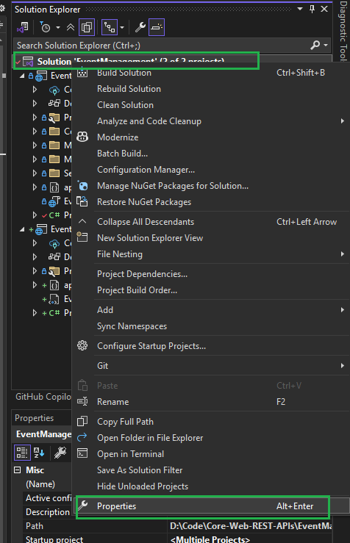

Apply to the following settings:
Api project should be open in ‘HTTPs’
HTML Client Project should be open the HTML client in the default browser
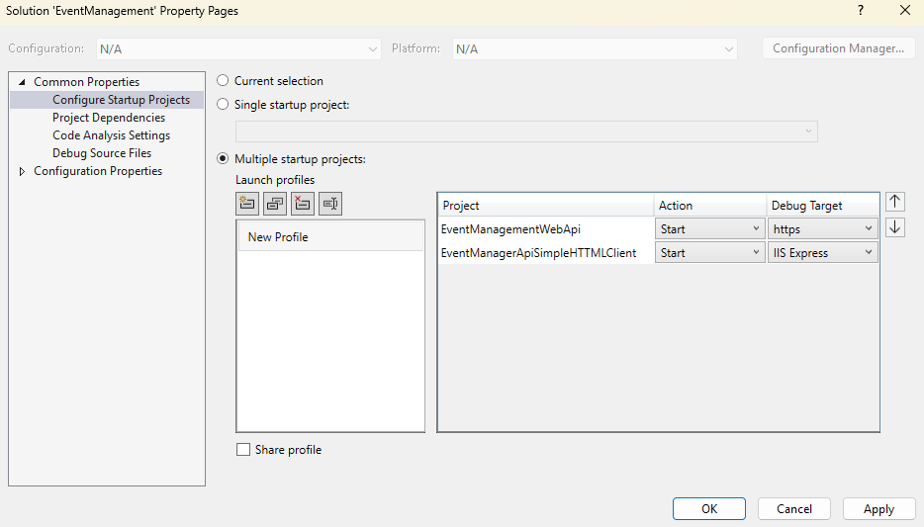

Create Blazor Client Application

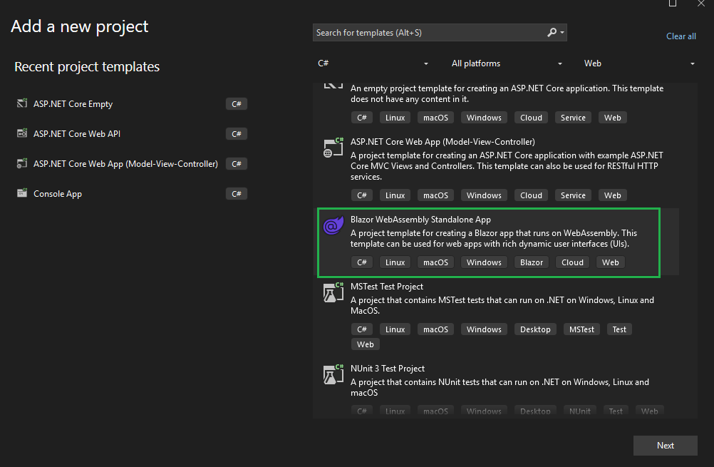

Project Name is ‘EventManagerBlazorApp’
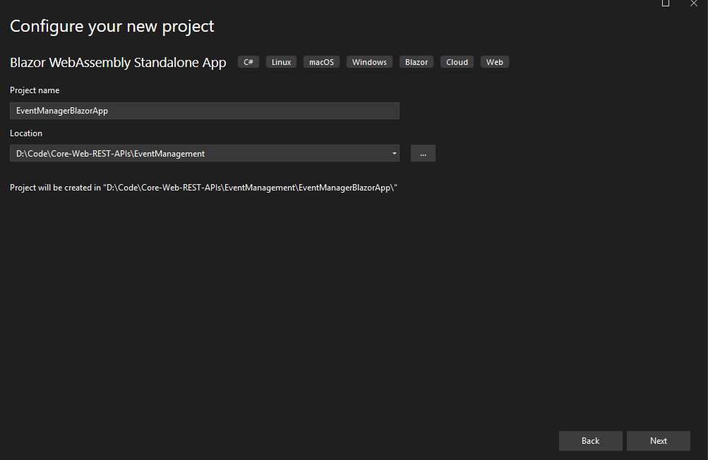
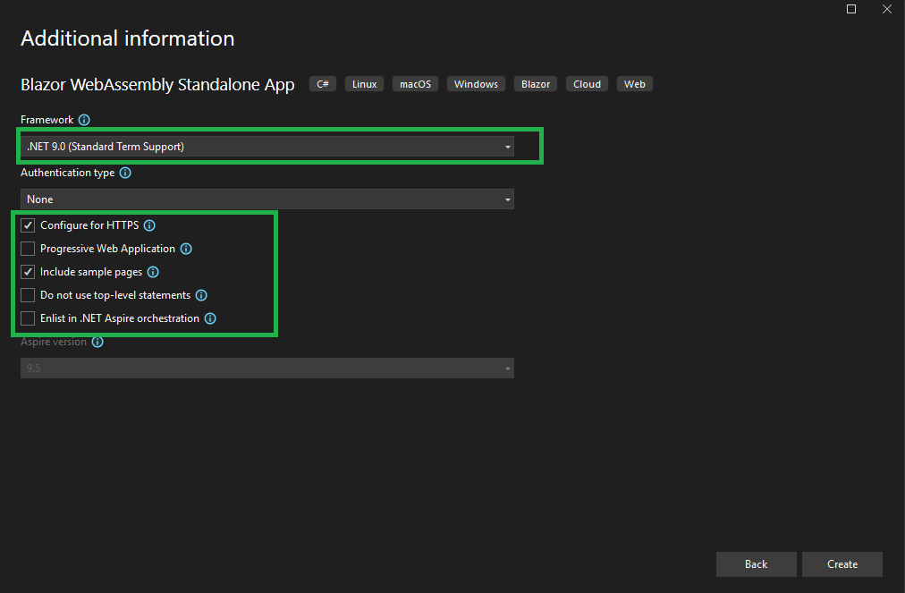

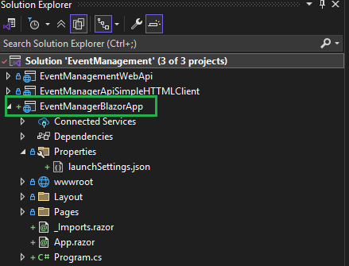

Set up the startup settings for the solution file
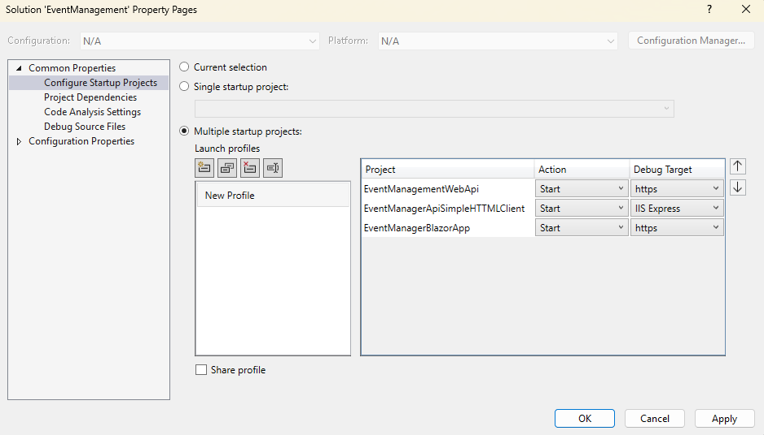

Configure HttpClient in the Blazor application to connect Web API

Open the ‘Program.cs’ file of the ‘EventManagerBlazorApp’ project
Configure HttpClient to connect to the Web API.
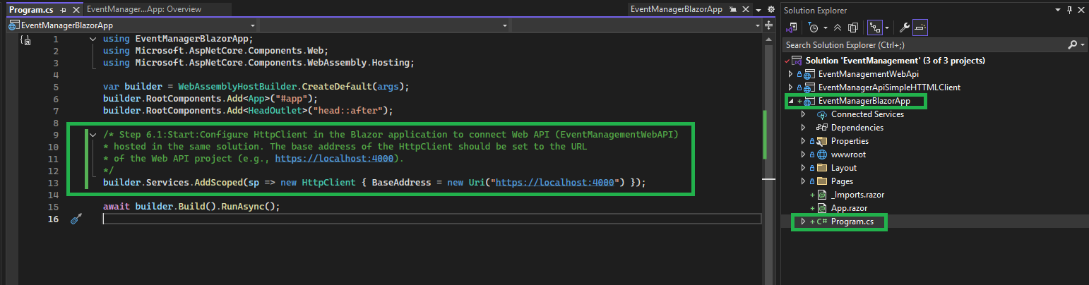

Create an ‘Events’ folder in ‘Pages’ of the project
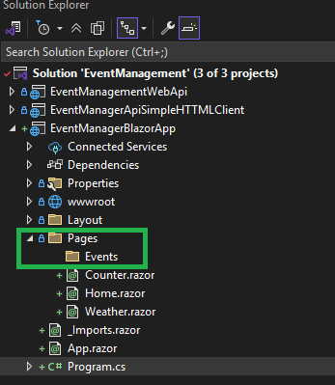

Add a new Blazor Component (EventList.razor) in the Events Folder
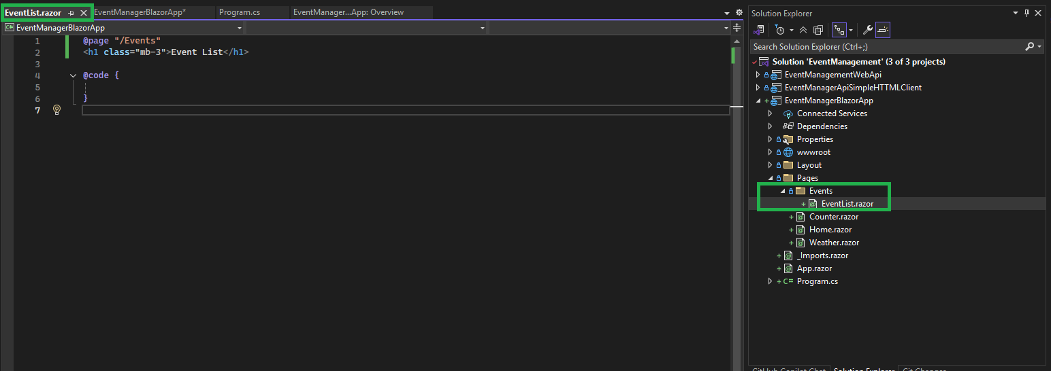

Add the EventList page reference in ‘NavMenu.razor’ under Layout folder

Step 01: Add icons
Go to the Google and search ‘bootstrap’ open ‘bootstrap’ page, Click to the icons
Search ‘Event’ and select any Icon which you like to display
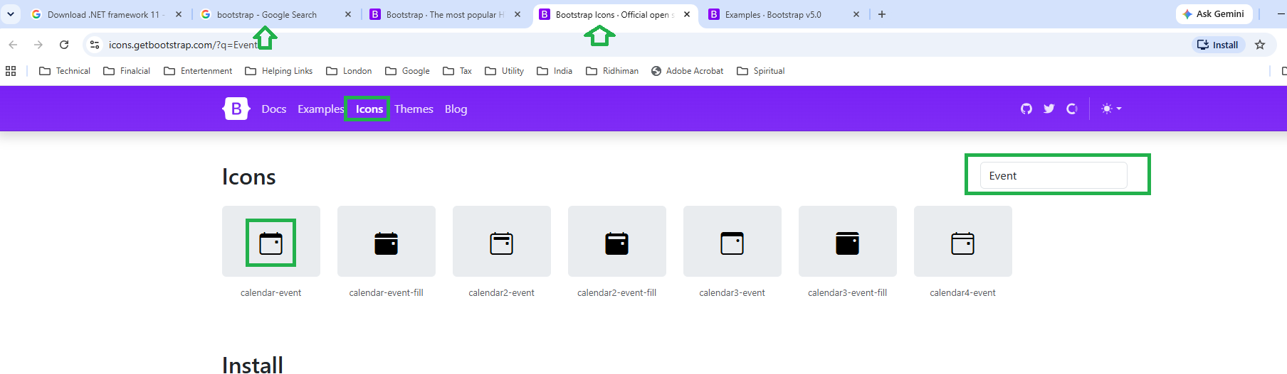

Copy the Svg for the Icon
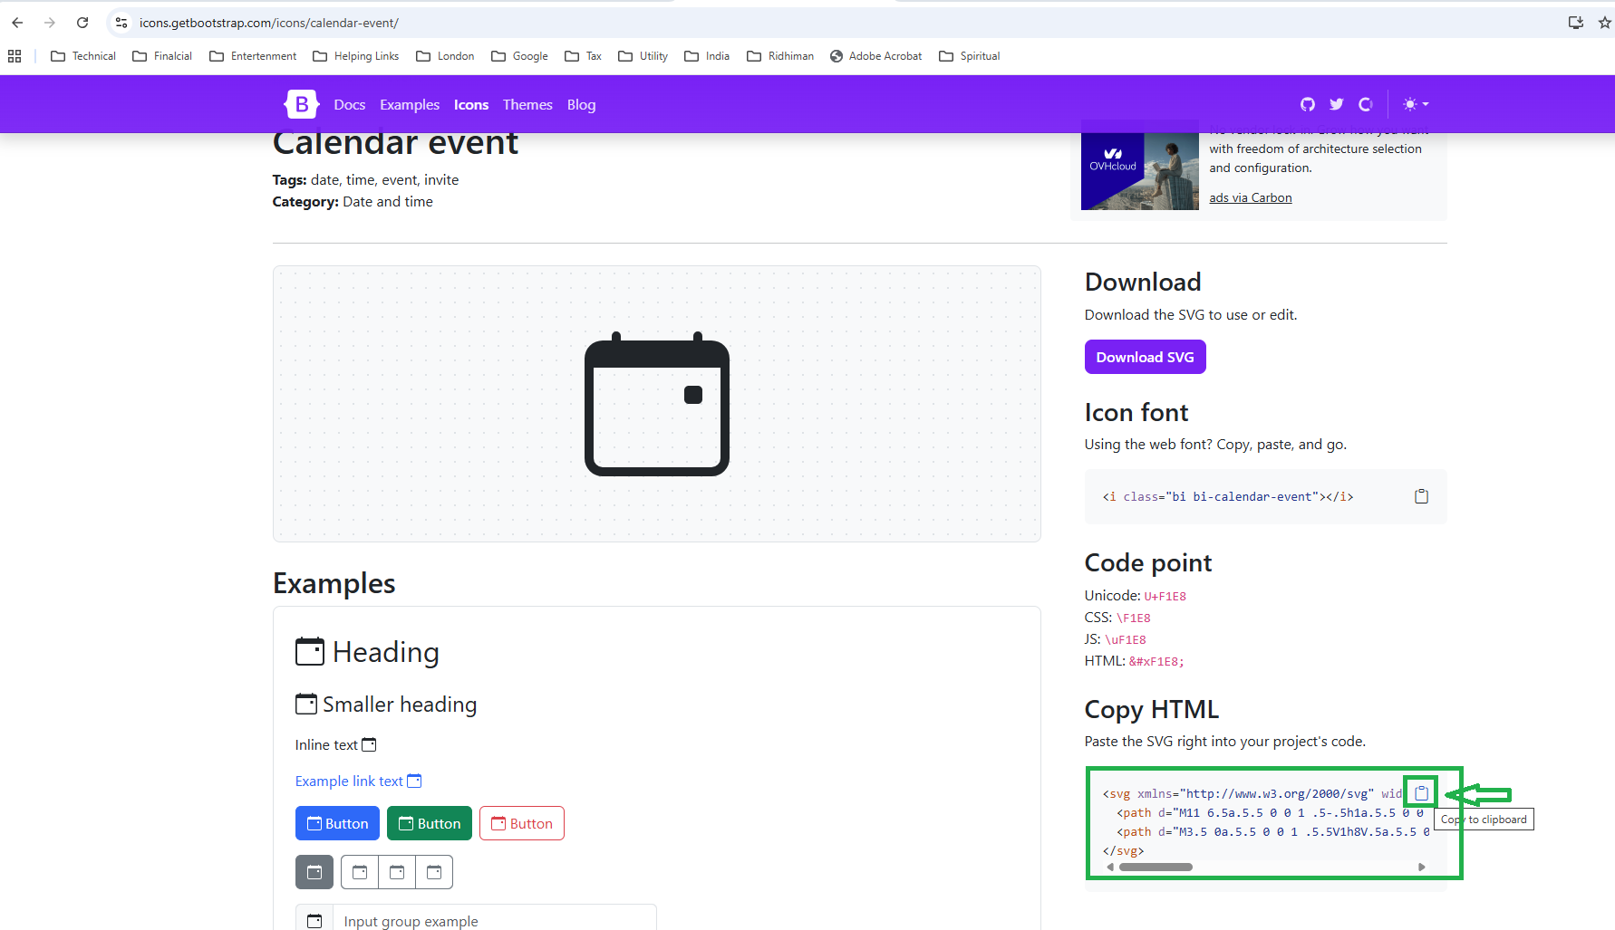

Replace the ‘Span’ tag with the following Bootstap icon text:
Text needs to be replaced | New applied copied text from Bootstrap page for icon; replace the old text
<span class="bi bi-list-nested-nav-menu" aria-hidden="true"></span> | <svg xmlns="http://www.w3.org/2000/svg" width="16" height="16" fill="currentColor" class="bi bi-calendar-event" viewBox="0 0 16 16">  <path d="M11 6.5a.5.5 0 0 1 .5-.5h1a.5.5 0 0 1 .5.5v1a.5.5 0 0 1-.5.5h-1a.5.5 0 0 1-.5-.5z"/>  <path d="M3.5 0a.5.5 0 0 1 .5.5V1h8V.5a.5.5 0 0 1 1 0V1h1a2 2 0 0 1 2 2v11a2 2 0 0 1-2 2H2a2 2 0 0 1-2-2V3a2 2 0 0 1 2-2h1V.5a.5.5 0 0 1 .5-.5M1 4v10a1 1 0 0 0 1 1h12a1 1 0 0 0 1-1V4z"/>  </svg>

Run the project
On the click of ‘Events’ navigation button pages getting open
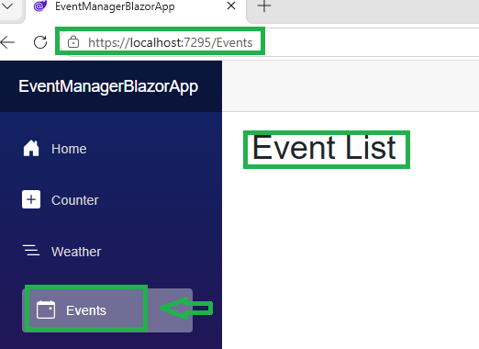

Add ‘Event’ Model class in the newly created folder ‘Models’
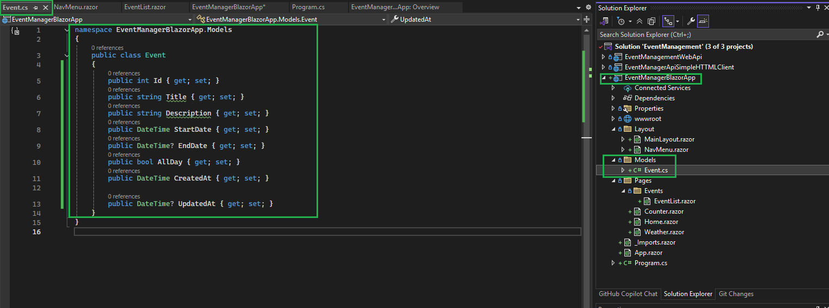

Write code to display Event List in Blazor Component page (EventList.razor) under folder ‘Pages=>Event’

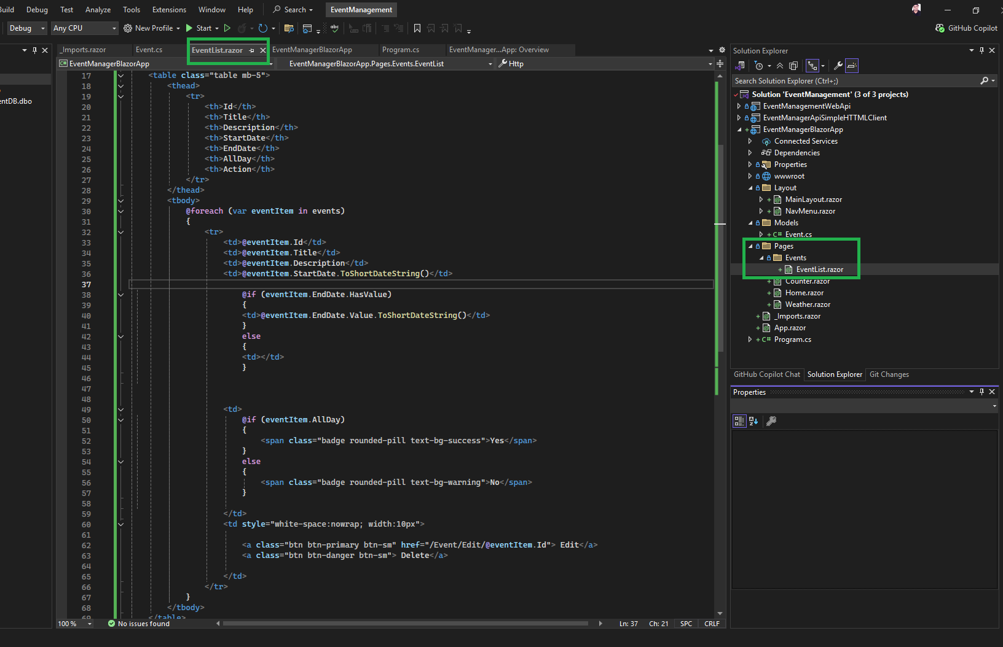

Video Time 32:23/48:14

Create Event

Create a new Model in ‘EventDto’ in the Model folder of the project ‘EventManagerBlazorApp’

Copy the properties from EventDto of the Web Api project and paste them into the EventDto class of the ‘EventManagerBlazorApp’ project.

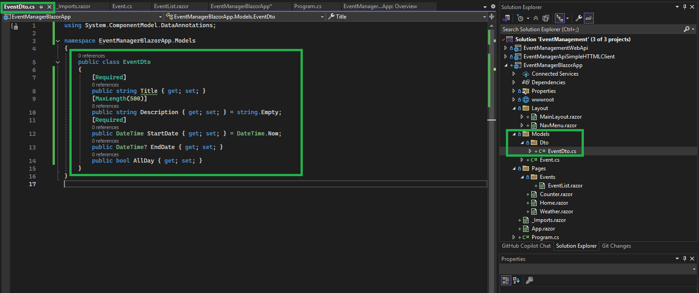

Create a new Blazor Component (Page) to create a new Event
Create a Blazor Component Page to create a new Event.

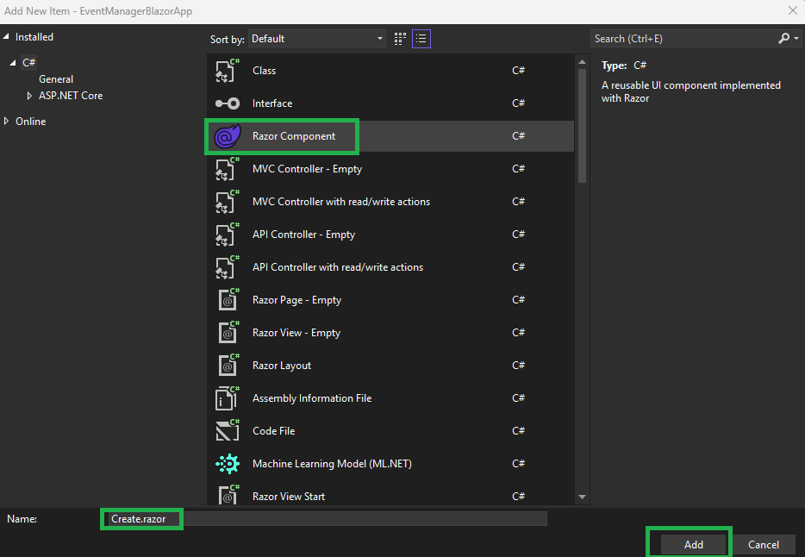
Complete the code of the Page ‘Create.razor’
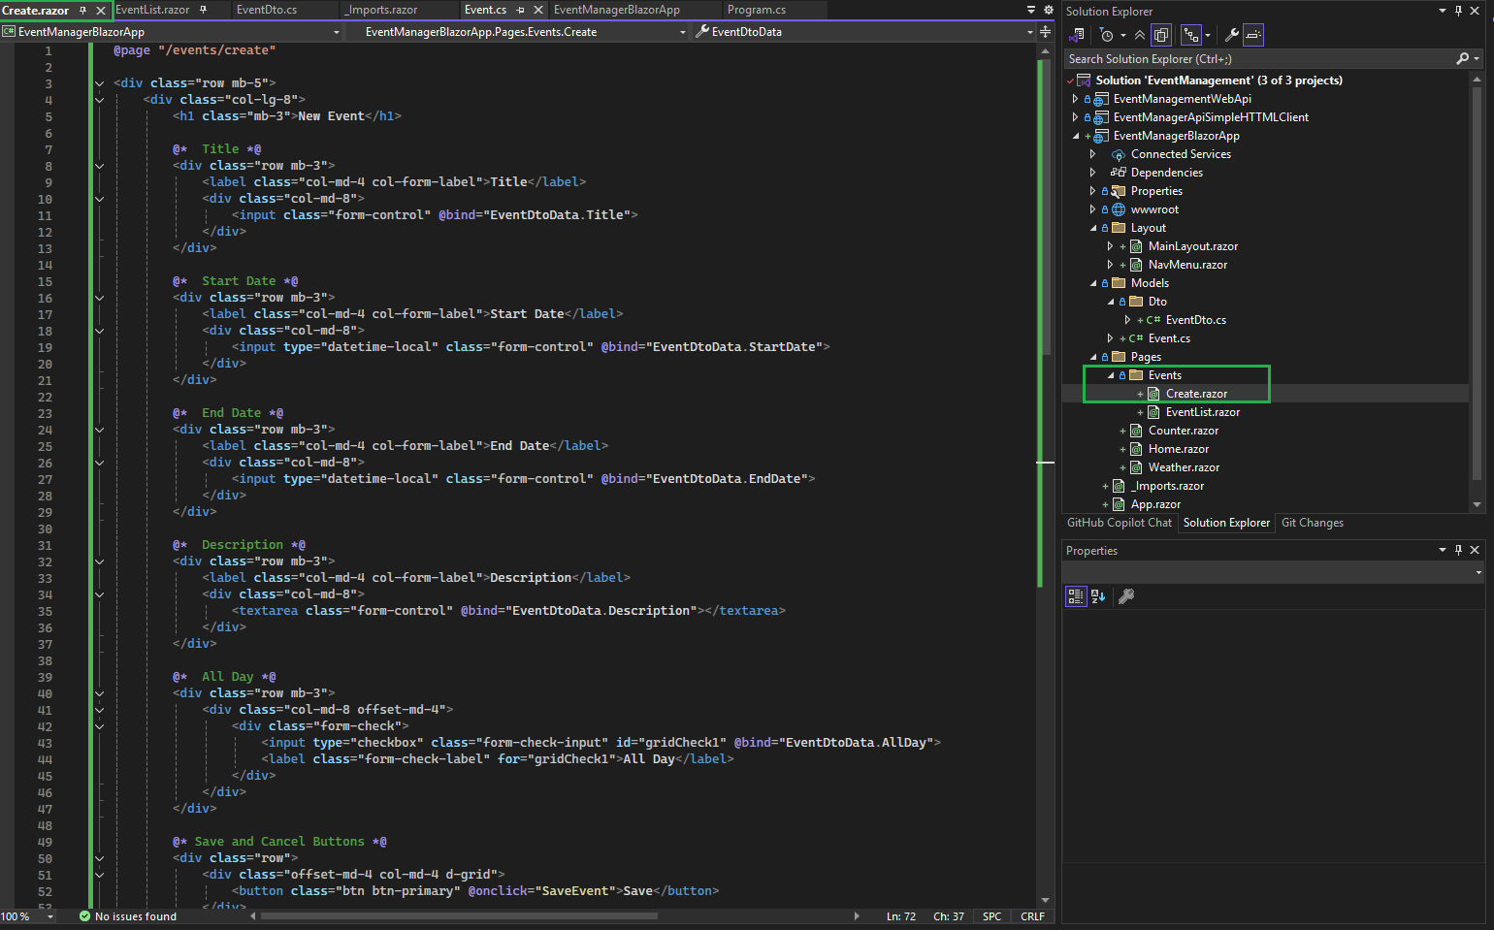

Run the Application and check the validation error sent by the API

Load the Page
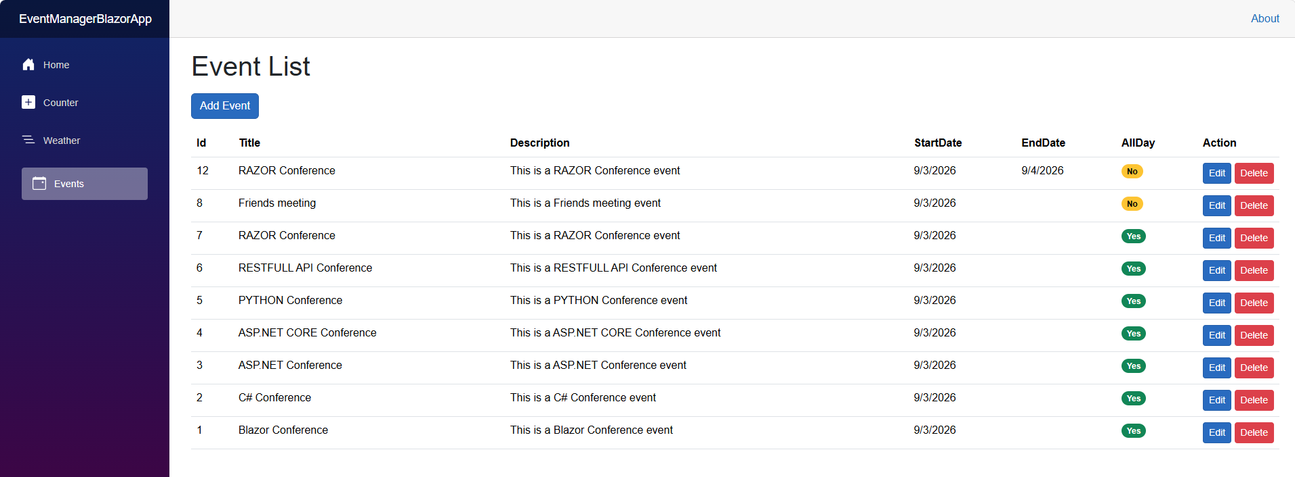

Click on ‘Add Event’ button
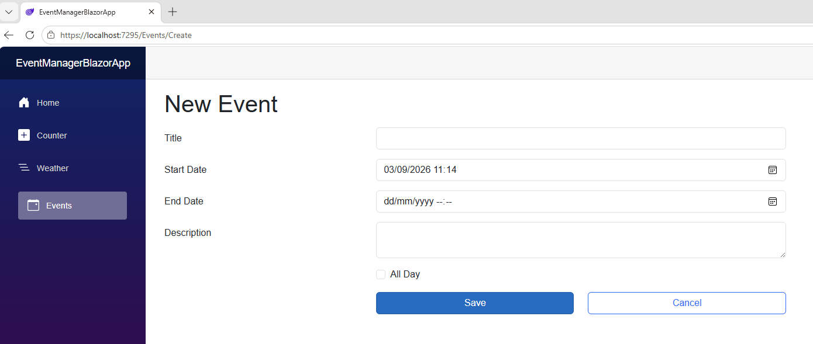

Verify the settings of the ‘Add Event’ button on the ‘EventList.razor’ Page
Check the ‘href’ Link should be same as ‘Create.razor’ file.

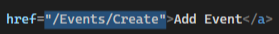 | 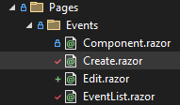

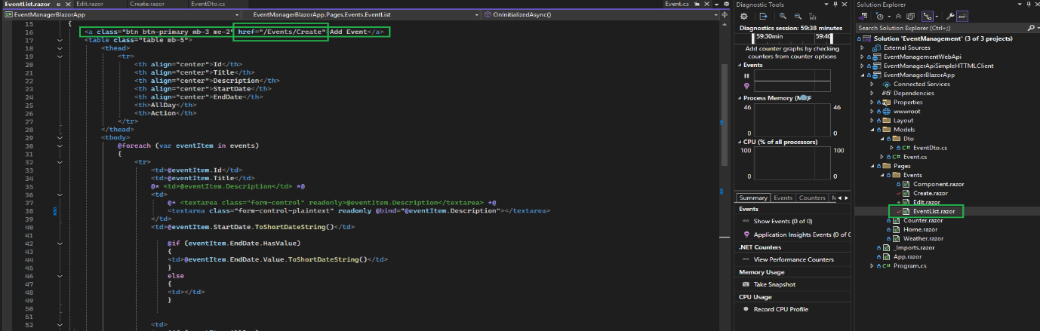

On Save and Cancel Button Click
- On Save button method SaveEvent() has been called

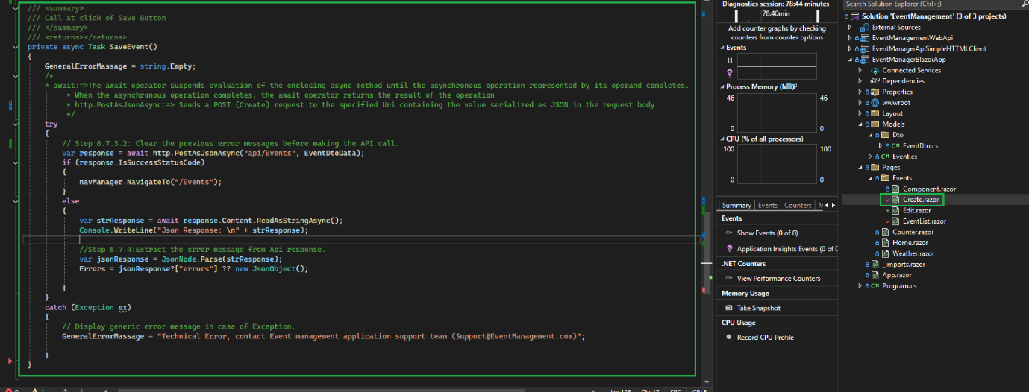

- On Cancel button click, redirected to the ‘EventList.razor’ page

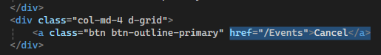

Click on the Save button without any value, like Title

No, Error message is displayed on the screen
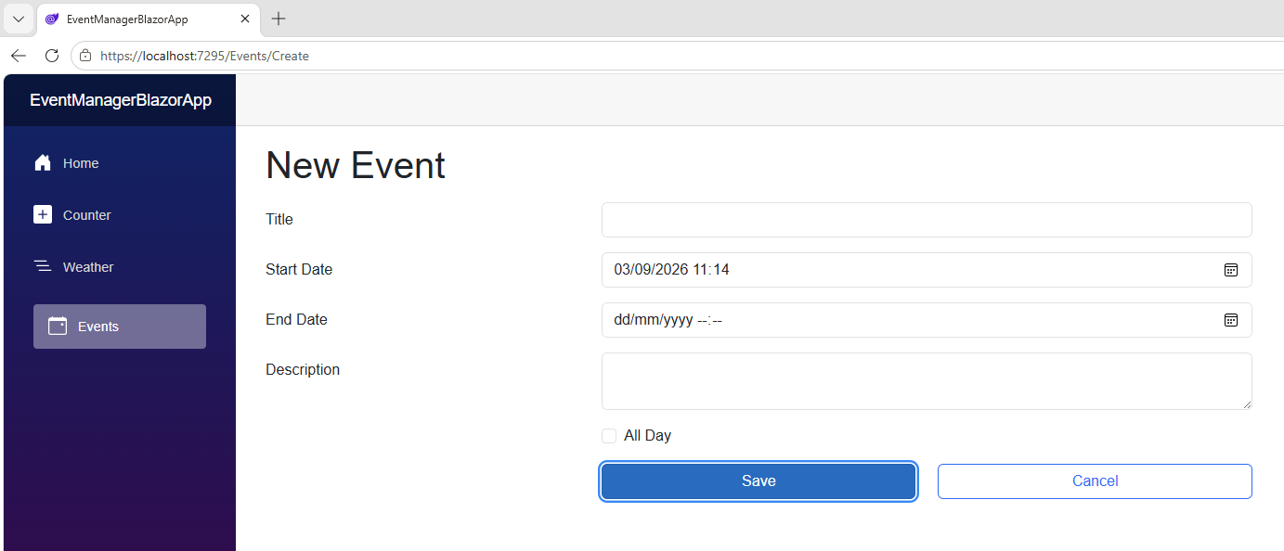

To see the API response message for validation error

Right click on page and click on ‘Inspect
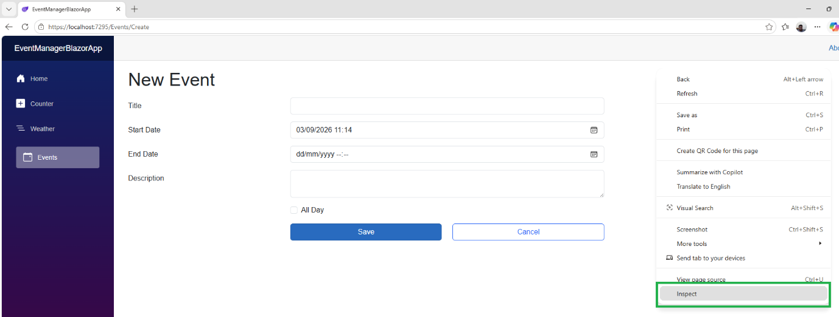

Go to the ‘Console’ and see the ‘JSON response’:
See the highlighted part
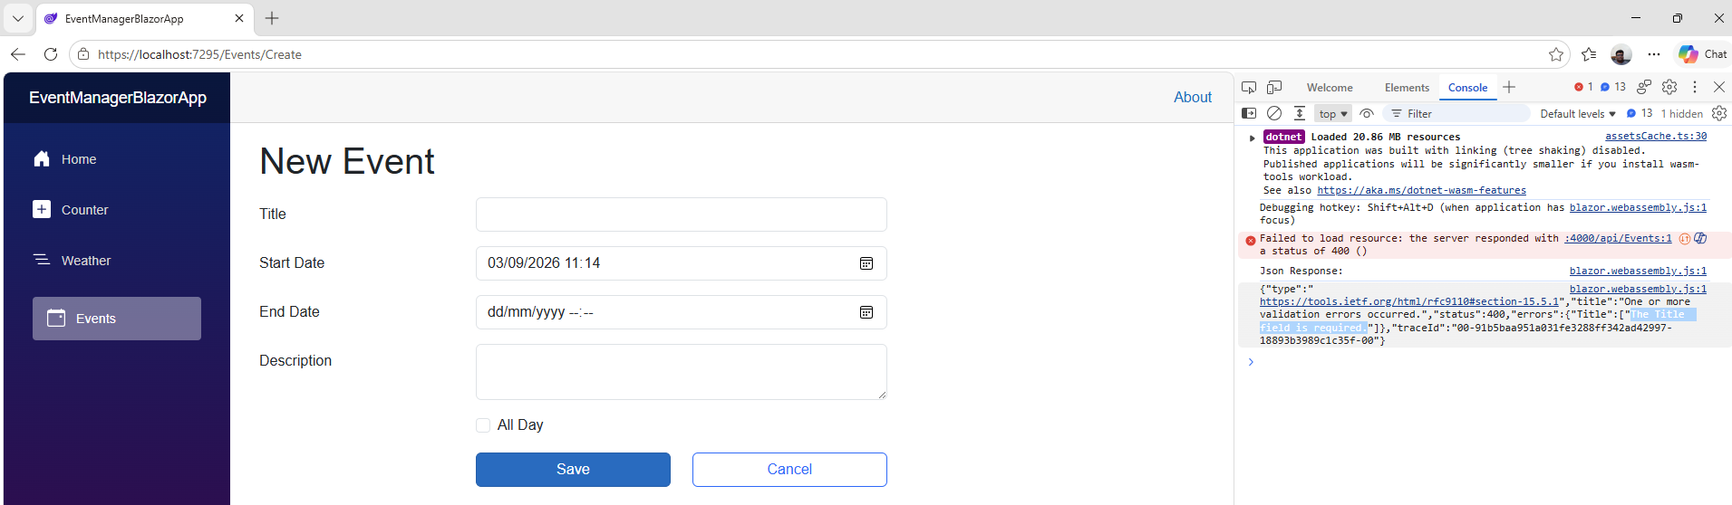

Code to show the validation message on the page sent by the API
Check the code under comments that start with (Step 6.7.4)
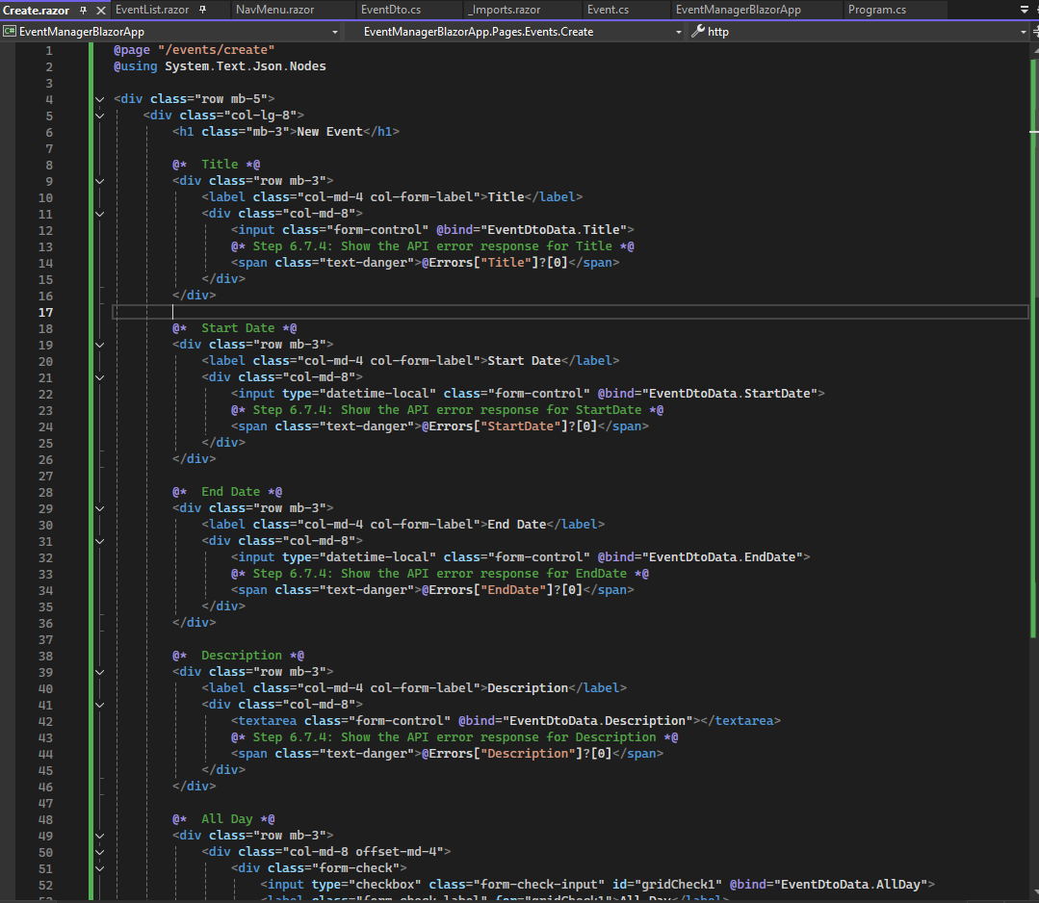

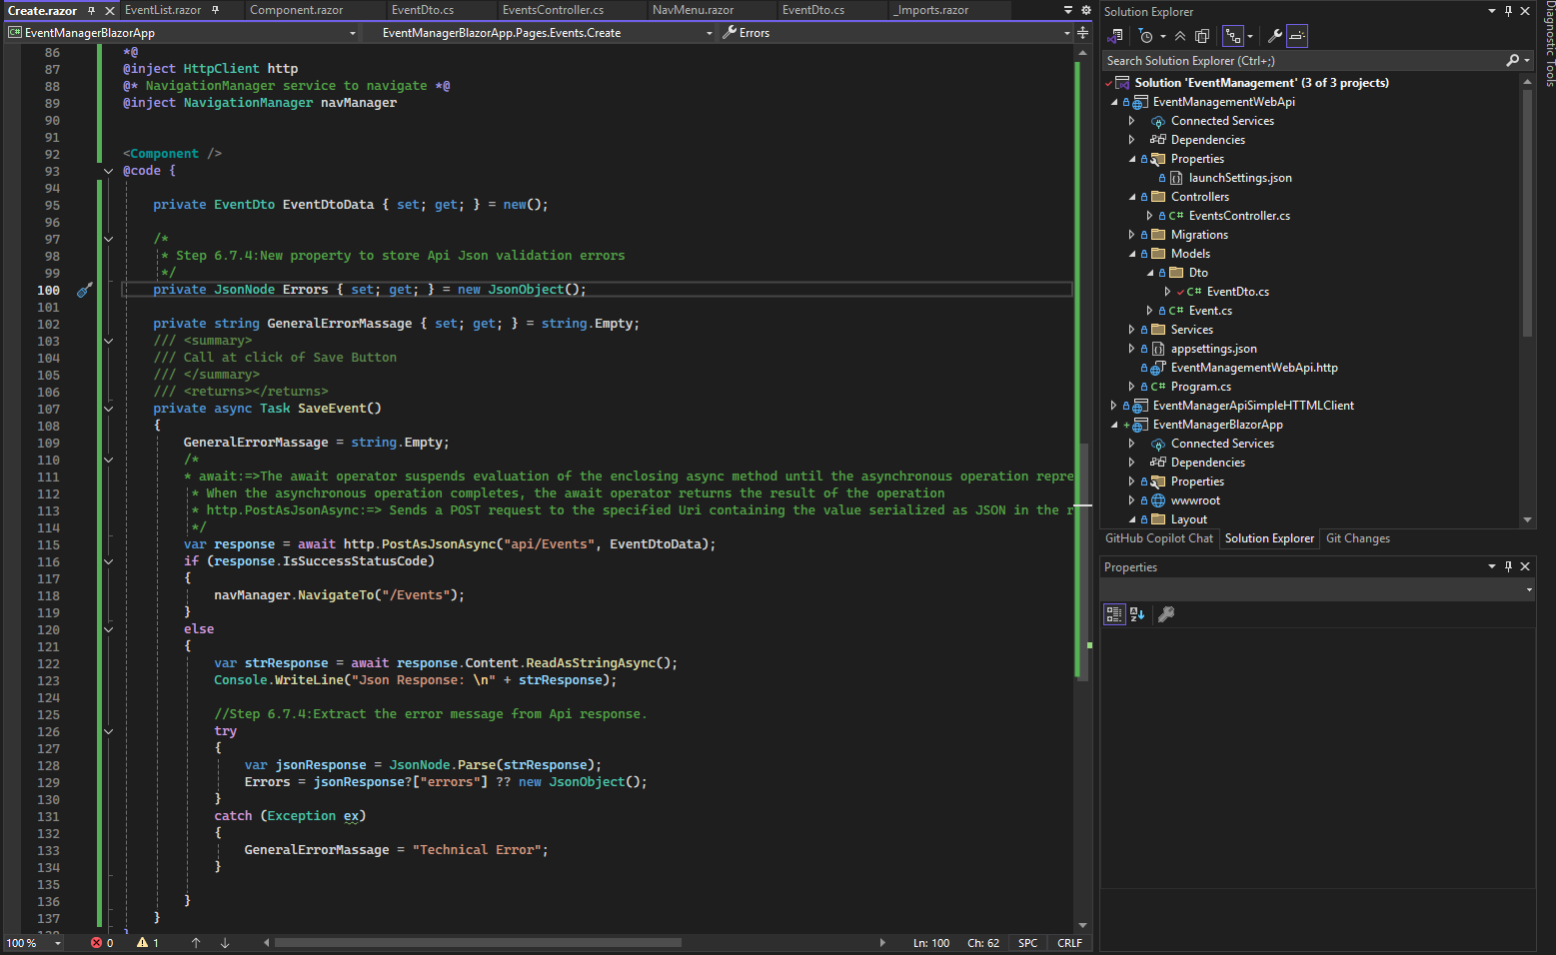

Run the application and observe its behaviour for the API response.
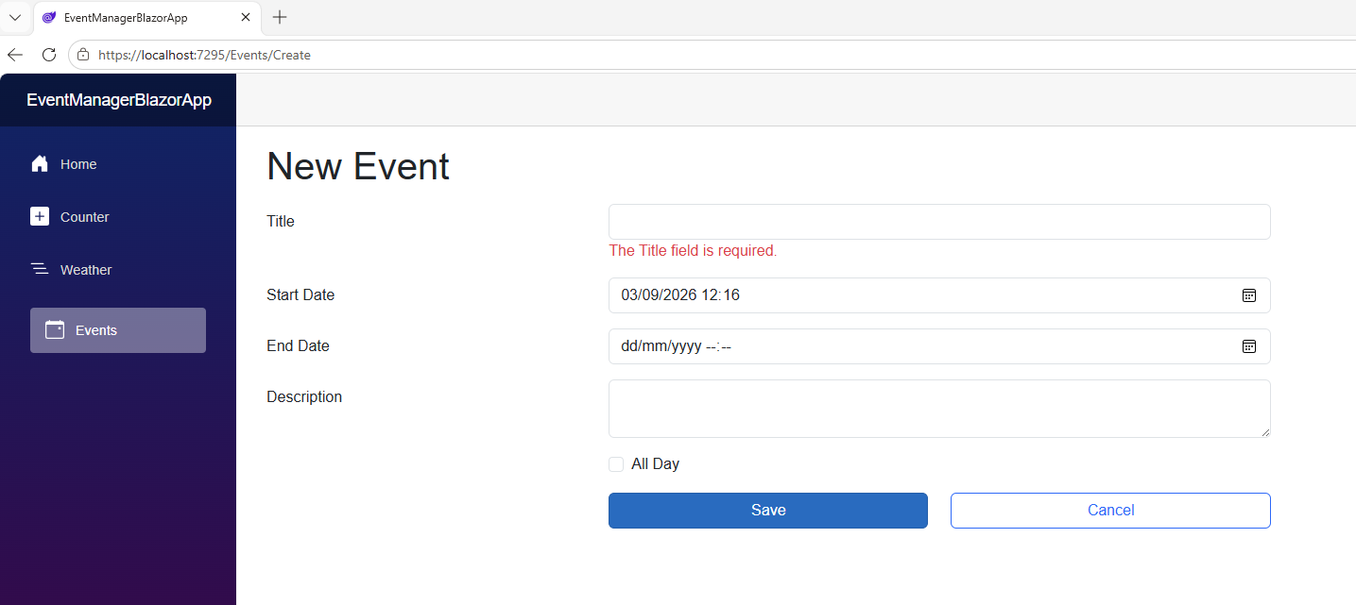

Update Event

On the ‘EventList.razor’, verify the Following

On ‘Edit’ Button ‘href’ the path should be same as File Path of ‘Edit.razor’

@eventItem.Id is a parameter for edit screen  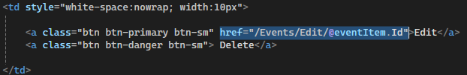 | 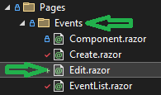

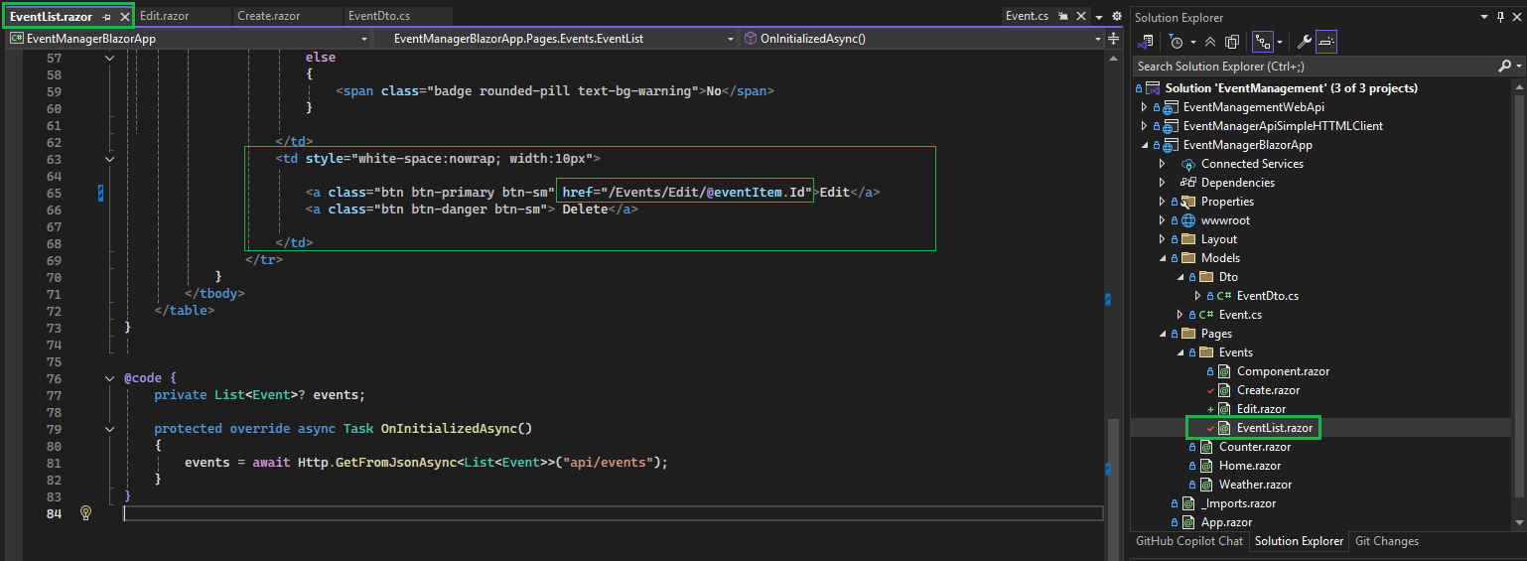

Write code to read the supplied parameter to fetch Event details for the Event ID parameter

- Create a new Property ‘EventId’
- Create a new override method ‘OnParametersSetAsync()’ to read Event details from Api after parameters are set.

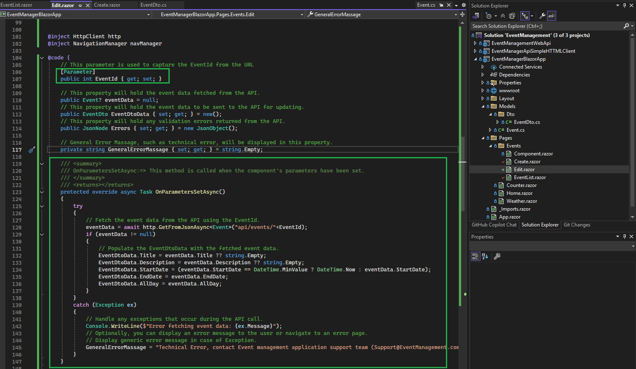

Complete the UI Design along with to display ‘Event ID’ in read-only mode

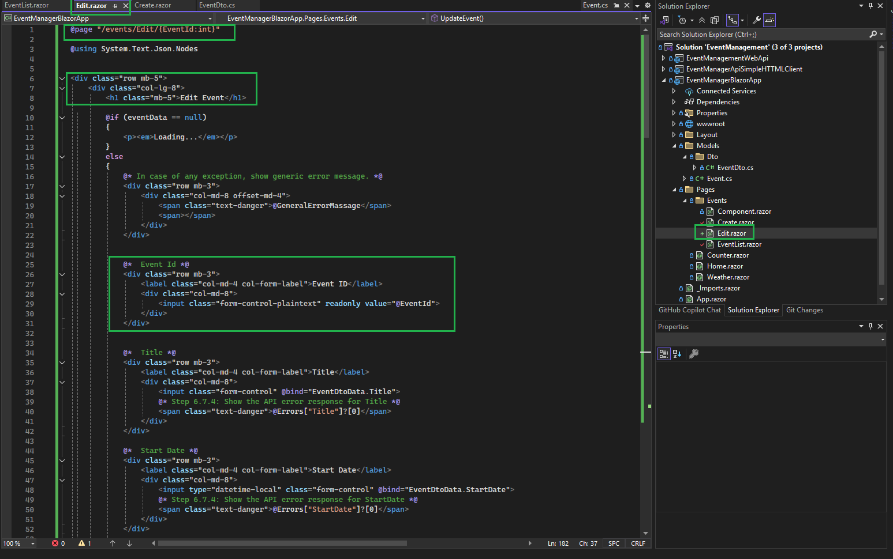

Write code for the Update and Cancel button clicks

Define OnClick events of Update and Cancel buttons.
On click of the ‘Cancel’ button, redirect to the ‘EventList.razor’ page.
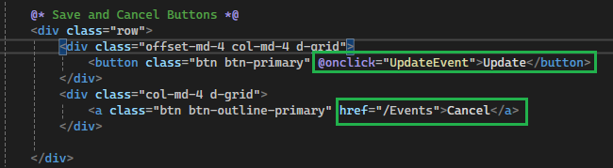

Write the code for ‘UpdateEvent()’ to call Api to validate and save updated values.

Call the Put Api method to update Event data

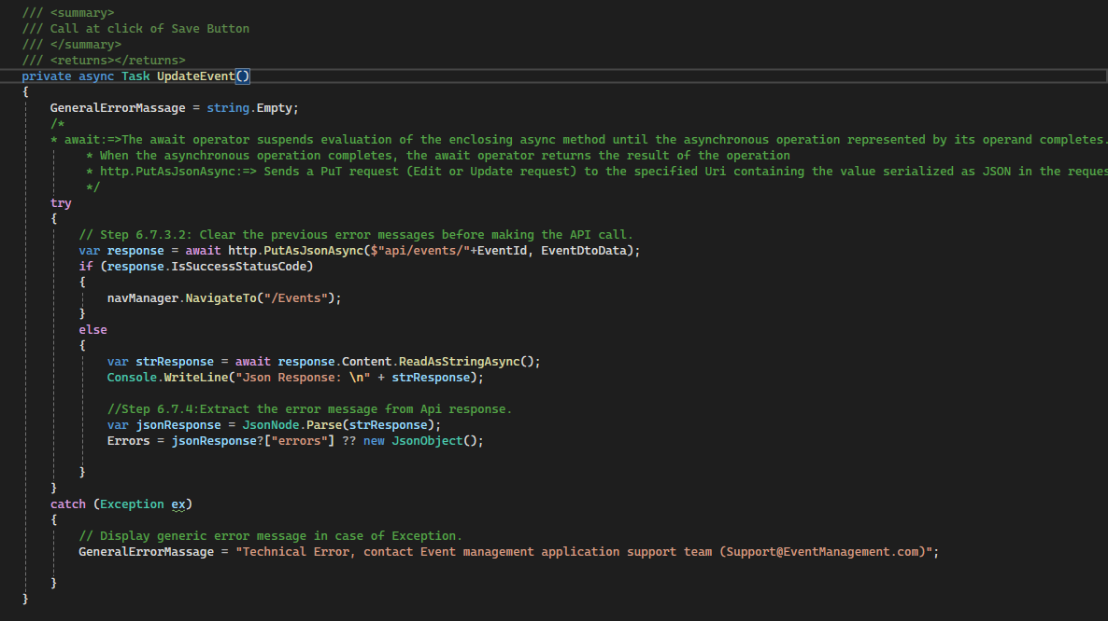

Execute the application to verify ‘Edit Event’ functionality

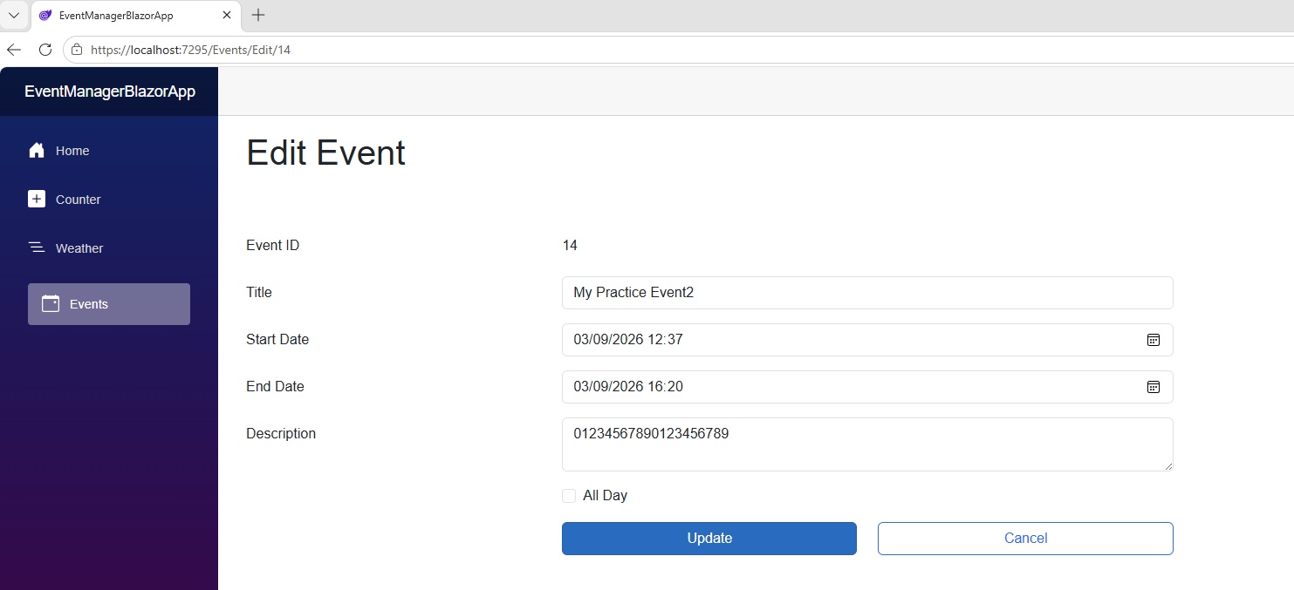

Delete Event

Write the ‘DeleteEvent’ method on the ‘EventList.razor’ page

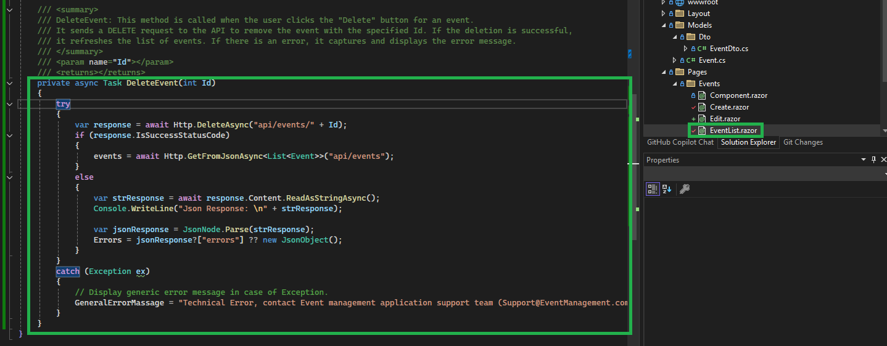

Call the ‘DeleteEvent’ method on the Delete Button click

Due to asynchronous call apply the following:

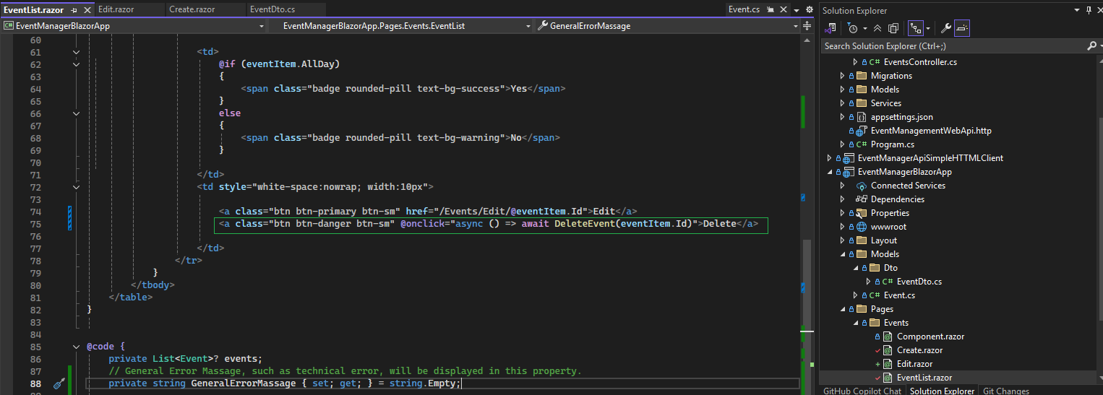

Reference

YouTube Video Title | YouTube Video Link
Create Event Management App using Blazor Web Assembly and SQL Server | CRUD Operations in .NET 9 | https://www.youtube.com/watch?v=dury9lKPt3M&t=2072s

